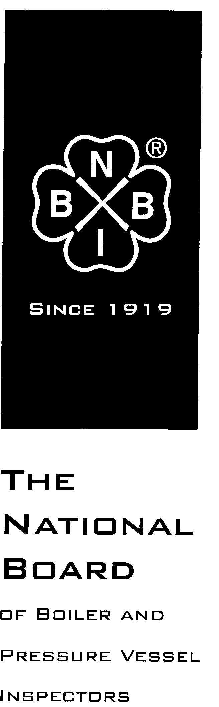

Date Distributed: October 29th, 2016

NATIONAL BOARD
INSPECTION CODE
COMMITTEE

AGENDA

Meeting of December 7th, 2016
WebEx Online Meeting

The National Board of Boiler & Pressure Vessel Inspectors
1055 Crupper Avenue
Columbus, Ohio 43229-1183
Phone: (614)888-8320
FAX: (614)847-1828

- Call to Order

Chair Mr. Don Cook called the meeting to order at 1:01pm Eastern time.

- Introduction of Members and Visitors

Mr. Cook invited Mr. Besserman to perform a roll call. The results of the roll call were as follows:

Present, Signed In To WebEx
Don Cook - Chair
Bradley Besserman - Secretary
Joel Amato
Sid Cammeresi
Paul Edwards
Craig Hopkins
Mark Mooney
Brian Morelock
Bryan Schulte
Jim Sekely
Stan Staniszewski
Rob Troutt

Present, Call In Only
George Galanes
Mike Richards

Not Present
Bob Wielgoszinski – Vice Chair
Larry McManamon
Venus Newton
Jim Pillow
Jim Riley
Kevin Simmons
Mike Webb
Paul Welch

- Adoption of the Agenda

The agenda was approved as published by a unanimous vote of the NBIC Committee.

- Approval of the 2017 Edition of the NBIC

Mr. Cook explained that all public review comments had been satisfactorily resolved. Mr. Besserman presented the document “2017 Draft Edition w Editorial Changes 12-6-16” for approval as the 2017 edition of the NBIC. The committee approved the document with a unanimous vote via the WebEx voting system. (Attachment 1)

- Future Meetings

January 9-12, 2017 – San Diego, California
July 17-20, 2017 – Columbus, Ohio

- Adjournment

The meeting was adjourned at 1:10pm Eastern time by Chair Mr. Don Cook.

Respectfully submitted,

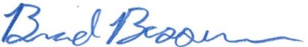
Brad Besserman
NBIC Secretary

