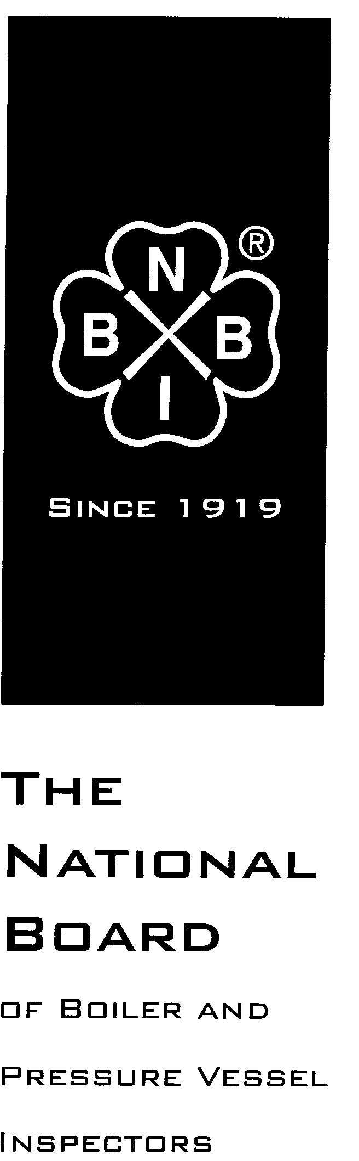

Date Distributed: August 3rd, 2017

NATIONAL BOARD
SUBGROUP
GRAPHITE

MINUTES

Meeting of July 18th, 2017
Columbus, Ohio

These minutes are subject to approval and are for committee use only. They are not to be duplicated or quoted for other than committee use.

The National Board of Boiler & Pressure Vessel Inspectors
1055 Crupper Avenue
Columbus, Ohio 43229-1183
Phone: (614)888-8320
FAX: (614)847-1828

- Call to Order

Chair Mr. Ed Soltow called the meeting to order at 9:05am local time.

- Introduction of Members and Visitors

The following people attended the meeting:

Ed Soltow – Chair
Brad Besserman - Secretary
Andy Stupica – Member
Francis Brown – Member
Bryan Jones – Member
Ramkumar Selveraj – Member
Justin Clemens – Member
Chris Cary – Member
Monte Bost – Visitor

- Announcements

It was announced that lunch would be provided by the National Board for all meetings. It was also announced that a reception would be held for all volunteers at the National Board Pavilion starting at 5pm on Wednesday night.

- Adoption of the Agenda
The agenda was adopted as published by a unanimous vote of SG Graphite.
- Approval of the Minutes of March 28th, 2017 Meeting

The minutes of the March 28th, 2017 meeting were published prior to the meeting on the National Board website, www.nationalboard.org. The committee reviewed the minutes from the previous meeting. The minutes were adopted as published by a unanimous vote of SG Graphite.

- Review of Rosters

  - Membership Nominations

Mr. Monte Bost submitted an application for membership to SG Graphite. SG Graphite voted unanimously to recommend Mr. Bost for appointment to SG Graphite.

  - Membership Reappointments

Mr. Aaron Viet was eligible for reappointment to SG Graphite. He expressed interest in continuing as a member of the committee. SG Graphite voted unanimously to recommend Mr. Viet for reappointment to SG Graphite.

- NBIC Business

Item Number: NB15-2208 | NBIC Location: Part 3, S3 | No Attachment
General Description: Investigate repair options for graphite block heat exchangers
Subgroup: Graphite

Task Group: G. Becherer (PM)

Meeting Action: A proposal was submitted to the secretary by Greg Becherer prior to the meeting. The proposal was reviewed by the committee and some comments were added. The committee chose to distribute the proposal by email for comment. A proposal should be ready for vote at the next meeting.

Item Number: NB15-2209 | NBIC Location: Part 1 | No Attachment
General Description: Develop guidance and requirements for installation of graphite pressure equipment
Subgroup: Graphite

Task Group: A. Stupica (PM)

Meeting Action: Prior to this meeting, a proposal was letter balloted to SG Graphite and received two disapproval votes. Discussion was held about the disapproval comments. The subgroup incorporated changes to the definition of impregnated graphite.

Item Number: NB15-2210 | NBIC Location: Part 3 | No Attachment
General Description: Reduce cementing requirements for plugging of tubes
Subgroup: Graphite

Task Group: C. Cary (PM)

Meeting Action: A proposal was drafted and approved by SG Graphite after the January 2017 meeting, but at the time of the meeting had not been acted on by SC Repairs and Alterations. The approved item was displayed to the committee members.

Item Number: NB16-1302 | NBIC Location: Part 3, S3.2 | No Attachment
General Description: Pressure test requirements rewrite for graphite vessels
Subgroup: Graphite

Task Group: None assigned

Meeting Action: A proposal was drafted and approved by SG Graphite after the January 2017 meeting, but at the time of the meeting had not been acted on by SC Repairs and Alterations. The approved item was displayed to the committee members.

Item Number: NB16-1303 | NBIC Location: Part 3, S3.5.1 f) | No Attachment
General Description: Revise wording mandating examination and evaluation for graphite vessels
Subgroup: Graphite

Task Group: None assigned

Meeting Action: A proposal was drafted and approved by SG Graphite after the January 2017 meeting, but at the time of the meeting had not been acted on by SC Repairs and Alterations. The approved item was displayed to the committee members.

Item Number: 17-165 | NBIC Location: Part 3, S3 | No Attachment
General Description: Change reimpregnation of graphite to routine repair
Subgroup: Graphite

Task Group: R. Selveraj (PM)

Meeting Action: Additional discussion was held about moving reimpregnation of graphite from the repair section of NBIC Part 3 to the routine repair section. Routine repairs in graphite were reviewed.

Item Number: 17-166 | NBIC Location: Part 3, S3 | No Attachment
General Description: Remove nozzle replacement and tube replacement from graphite routine repair list
Subgroup: Graphite

Task Group: F. Brown (PM)

Meeting Action: This item was opened by the committee after discussion that the graphite related routine repairs list was too broad.

Item Number: 17-167 | NBIC Location: Part 3, S3 | No Attachment
General Description: Clarify repair inspection requirements for machined only graphite parts
Subgroup: Graphite

Task Group: A. Viet

Meeting Action: Discussion was held about how to handle machined only graphite pieces. The main question discussed was whether a machined only part needs inspection from an AI. The part has partial data report, so the committee agreed that it does not require shop inspection by AI. This item was opened to clarify repair inspection requirements regarding machined only graphite parts.

- Future Meetings

- November, 2017 – Columbus, OH
- Spring 2018 – Columbus, OH

- Adjournment

The meeting was adjourned by Mr. Soltow at 11:32am local time.

Respectfully submitted,

Brad Besserman
NBIC Secretary

