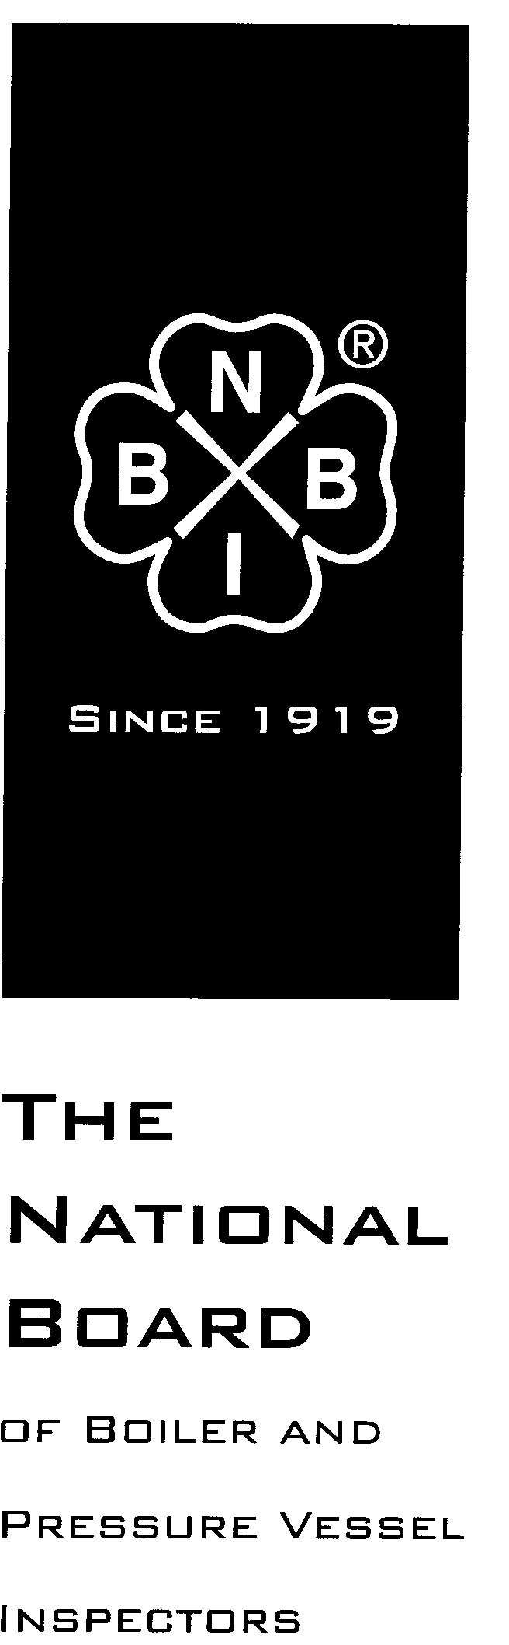

Date Distributed: March 30th, 2017

NATIONAL BOARD
SUBGROUP
GRAPHITE

MINUTES

Meeting of March 28th, 2017
Columbus, OH

These minutes are subject to approval and are for committee use only. They are not to be duplicated or quoted for other than committee use.

The National Board of Boiler & Pressure Vessel Inspectors
1055 Crupper Avenue
Columbus, Ohio 43229-1183
Phone: (614)888-8320
FAX: (614)847-1828

- Call to Order

Subgroup Graphite Chair Mr. Ed Soltow called the meeting to order at 9:05am local time.

- Introduction of Members and Visitors

Mr. Soltow invited all members and visitors to introduce themselves. The following were in attendance:

- Ed Soltow – Chair
- Brad Besserman – Secretary
- Chris Cary – Member
- Aaron Viet – Member
- Justin Clemens – Member
- Bryan Jones – Member
- Andrew Stupica – Member
- Francis Brown – Member
- Greg Becherer – Member
- Gary Scribner – Visitor

- Announcements

Mr. Scribner announced that the 2017 edition of the NBIC was in the final stages of review and will be available for purchase on July 1st, 2017.

- Adoption of the Agenda
The agenda was adopted as published by a unanimous vote of SG Graphite.

- Approval of the Minutes of October 26th, 2016 Meeting

The committee reviewed the minutes which were posted on the National Board website. The minutes were approved as posted by a unanimous vote of SG Graphite.

- Action Items

Item Number: NB15-2208 | NBIC Location: Part 3, S3 | No Attachment
General Description: Investigate repair options for graphite block heat exchangers
Subgroup: Graphite

Task Group: Greg Becherer (PM)

Meeting Action: Mr. Becherer reported that no progress had been made on this item. He stated that a proposal should be ready for review at the July 2017 SG Graphite meeting.

Item Number: NB15-2209 | NBIC Location: Part 1 | Attachment Pages 1-5
General Description: Develop guidance and requirements for installation of graphite pressure equipment
Subgroup: Graphite

Task Group: A. Stupica (PM)

Meeting Action: Mr. Francis Brown presented comments on the proposal that was distributed in the agenda attachments. The committee modified the proposal based on Mr. Brown’s comments, and made some additional modifications. The committee requested that the item be sent out for a review and comment ballot, and then followed by and up/down ballot.

Item Number: NB15-2210 | NBIC Location: Part 3 | Attachment Page 6
General Description: Reduce cementing requirements for plugging of tubes
Subgroup: Graphite

Task Group: C. Cary (PM)

Meeting Action: This item was previously balloted to SC Repairs and Alterations, but did not pass. SC Repairs and Alterations member Mr. Mike Webb submitted a revised proposal during the ballot period. The committee reviewed the revised proposal, and added some additional modifications. The committee requested that the item be sent out for up/down ballot.

Item Number: NB16-1302 | NBIC Location: Part 3, S3.2 | Attachment Page 7
General Description: Pressure test requirements rewrite for graphite vessels
Subgroup: Graphite

Task Group: None assigned

Meeting Action: This item was previously approved by SG Graphite at the July 2016 meeting. The proposal is awaiting action by SC Repairs and Alterations.

Item Number: NB16-1303 | NBIC Location: Part 3, S3.5.1 f) | Attachment Page 8
General Description: Revise wording mandating examination and evaluation for graphite vessels
Subgroup: Graphite

Task Group: None assigned

Meeting Action: This item was previously approved by SG Graphite at the July 2016 meeting. The proposal is awaiting action by SC Repairs and Alterations.

- Future Meetings

SG Graphite will meet in conjunction with ASME SG-GPE on July 18th-19th, 2017 at the National Board Headquarters in Columbus, Ohio.

- Adjournment

Mr. Ed Soltow adjourned the meeting at 4:10pm local time.

Respectfully submitted,

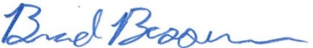
Brad Besserman
NBIC Secretary

