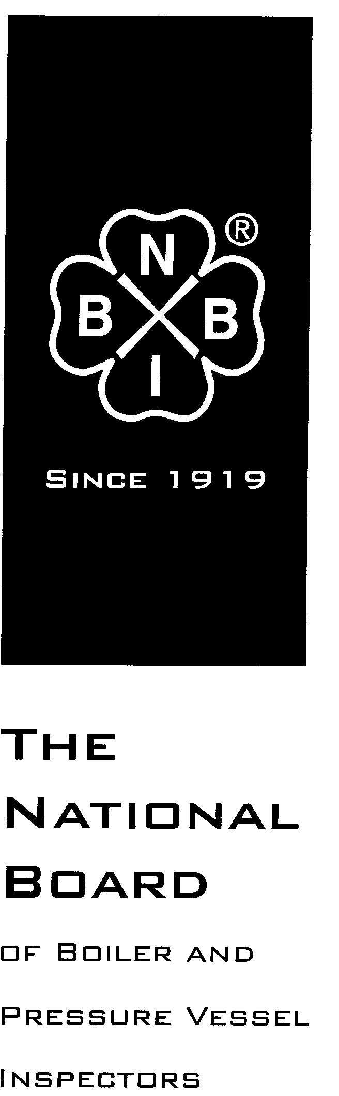

Date Distributed: April 9, 2018

NATIONAL BOARD
SUBGROUP
GRAPHITE

MINUTES

Meeting of March 27th, 2018
Columbus, Ohio

These minutes are subject to approval and are for committee use only. They are not to be duplicated or quoted for other than committee use.

The National Board of Boiler & Pressure Vessel Inspectors
1055 Crupper Avenue
Columbus, Ohio 43229-1183
Phone: (614)888-8320
FAX: (614)847-1828

- Call to Order

Acting Chair Mr. Aaron Viet called the meeting to order at 9:18 a.m.

- Introduction of Members and Visitors

Mr. Viet asked all who were present to introduce themselves. The following people were in attendance:

Andrew Stupica - member
Mote Bost - member
Chris Cary - member
Aaron Viet - member
Bryan Jones – member
Francis Brown - member
Jonathan Ellis – secretary
Nolan Lee – visitor
Caleb Krichbaum – visitor
Brian Burns – visitor
Gary Scribner - visitor

- Announcements

Mr. Andrew Stupica announced that Mr. Ed Soltow is no longer working in the graphite boiler industry, and has stepped down from the Graphite Subgroup. As he was the Chairman of the Subgroup, a new Chairman will need to be selected.

- Adoption of the Agenda

Mr. Viet moved to adopt the agenda as written. The motion was seconded and then approved unanimously.

- Approval of the Minutes of March 27th, 2018 Meeting

The minutes of the March 27th, 2018 meeting will be published on the National Board website, www.nationalboard.org.

- Review of Rosters

  - Membership Nominations
    - Mr. Ramkumar Selveraj will need to be replaced, but no decision was made on who will be nominated to replace him.
  - Membership Reappointments
    - The group voted unanimously to nominate Mr. Greg Becherer for reappointment.
  - Officer Nominations
    - Mr. Aaron Viet was voted to be the acting chair for this meeting. Mr. Viet then asked for a ballot to be sent out to the entire subgroup after the meeting to vote on a permanent chair for the subgroup. Mr. Viet and Mr. Stupica will be the two names on this ballot.

- NBIC Business

Item Number: NB15-2208 | NBIC Location: Part 3, S3 | No Attachment
General Description: Investigate repair options for graphite block heat exchangers
Subgroup: Graphite

Task Group: G. Becherer (PM)

Meeting Action: No new updates were presented at this meeting for this item, as Mr. Becherer was not present. Mr. Viet will get in touch with Mr. Becherer after the meeting to about progress on the item.

Item Number: NB15-2209 | NBIC Location: Part 1 | No Attachment
General Description: Develop guidance and requirements for installation of graphite pressure equipment
Subgroup: Graphite

Task Group: A. Stupica (PM)

Meeting Action: This item was approved by Main Committee via letter ballot.

Item Number: NB15-2210 | NBIC Location: Part 3 | No Attachment
General Description: Reduce cementing requirements for plugging of tubes
Subgroup: Graphite

Task Group: C. Cary (PM)

Meeting Action: This item was at Main Committee letter ballot when this meeting took place. As there were multiple disapproval comments, the group discussed them and what they could do before the Jly meeting to prepare a new proposal to present to the Main committee at the July 2018 NBIC meeting. The group agreed that clarification needed be made for the “Twist Test”. The group will prepare a new proposal by May 1, and the proposal will be balloted up to Main Committee before the July NBIC meeting.

Item Number: 17-165 | NBIC Location: Part 3, S3 | No Attachment
General Description: Change reimpregnation of graphite to routine repair
Subgroup: Graphite

Task Group: R. Selveraj (PM)

Meeting Action: After discussing this item, the group decided to close it with no action as they did not recall why this needed to be addressed.

Item Number: 17-166 | NBIC Location: Part 3, S3 | No Attachment
General Description: Remove nozzle replacement and tube replacement from graphite routine repair list
Subgroup: Graphite

Task Group: F. Brown (PM)

Meeting Action: Mr. Francis Brown will have a proposal prepared for presentation at the July NBIC meeting.

Item Number: 17-167 | NBIC Location: Part 3, S3 | No Attachment
General Description: Clarify repair inspection requirements for machined only graphite parts
Subgroup: Graphite

Task Group: A. Viet

Meeting Action: Discussion was held on the documentation and inspection requirements for machined graphite parts. Mr. Monte Bost and Mr. Viet will work together to create and present a proposal at the July meeting to address this item.

- Future Meetings

- July 17th and 18th – Columbus, Ohio
- TBD (most likely in November) – Columbus, OH

- Adjournment

Mr. Viet adjourned the meeting at 1:33 p.m.

Respectfully submitted,

Jonathan Ellis
Jonathan Ellis
NBIC Secretary

