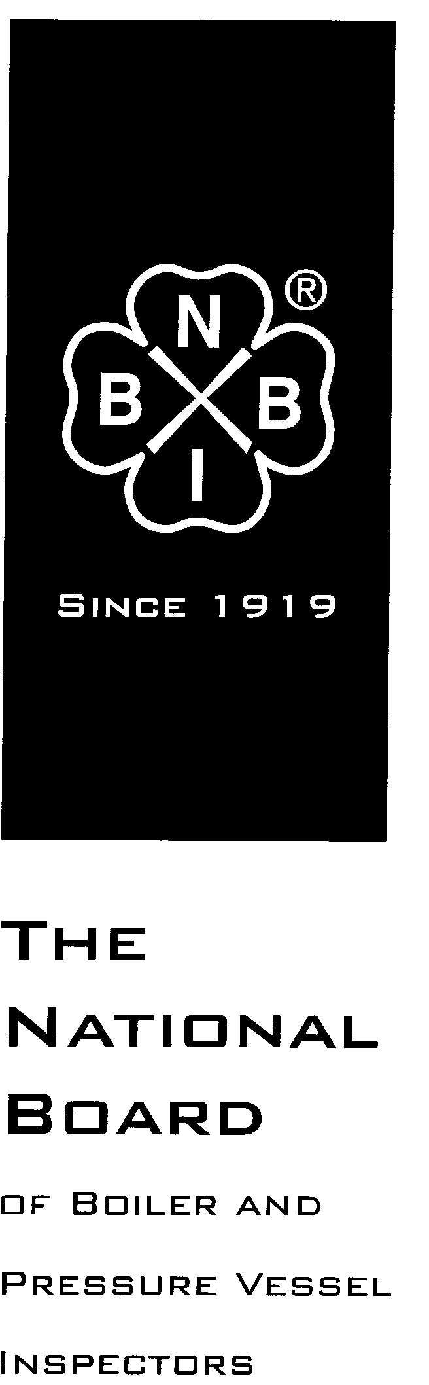

Date Distributed: 12-DEC-2018

NATIONAL BOARD
SUBGROUP
GRAPHITE

MINUTES

Meeting of October 24th, 2018
Clearwater Beach, Florida

These minutes are subject to approval and are for committee use only. They are not to be duplicated or quoted for other than committee use.

The National Board of Boiler & Pressure Vessel Inspectors
1055 Crupper Avenue
Columbus, Ohio 43229-1183
Phone: (614)888-8320
FAX: (614)847-1828

- Call to Order

Chair Mr. Aaron Viet called the meeting to order at 11:30 am local time.

- Introduction of Members and Visitors

Mr. Chris Cary will record minutes for the meeting as Mr. Jonathan Ellis is unable to attend.

Visitors Mr. Richard Bulgin (SGL) and Mr. Nolan Lee (Mersen) were introduced.

The following Members or Alternates were in attendance:

Aaron Viet – Chair
Jamela Aleshire – Alternate for Bob Dickerson
Gregory Becherer – Member
Chris Cary – Member
Justin Clements - Member
Andrew Stupica - Member

The following members were absent:

Jonathan Ellis - Secretary
Monte Bost - Member
Francis Brown – Member
Keith Cummins – Member
Bob Dickerson – Member - represented by Ms. Aleshire

Six of 10 members were present or represented by an Alternate.

- Announcements

None.

- Adoption of the Agenda

A motion was made, seconded, and unanimously approved to adopt the agenda with no additions.

- Approval of the Minutes of March 27th, 2018 Meeting

The minutes from the July 2018 meeting can be found on the National Board website -

https://www.nationalboard.org/SiteDocuments/NBIC%20Restricted/Graphite%20minutes%20with%20attachments.pdf

A motion was made, seconded, and unanimously approved to adopt the July 2018 minutes with no changes.

- Review of Rosters

  - Membership Nominations
    - No new nominations.
  - Membership reappointments
    - No actions taken. The next membership expiration is that of Mr. Brown on January 30, 2019. Mr. Cary to notify Mr. Ellis to determine course of action.
  - Officer nominations
    - No new nominations.

- NBIC Business

Item Number: NB15-2208 | NBIC Location: Part 3, S3 | No Attachment
General Description: Investigate repair options for graphite block heat exchangers
Subgroup: Graphite

Task Group: G. Becherer (PM)

Meeting Action: Mr. Greg Becherer presented a list of types of repairs to cylindrical blocks, which was discussed and expanded by the Subgroup, touching on inlay/chip repairs, skim cutting of gasket surfaces, reimpregnation and circumferential metal bands. It was agreed that a hole plugging procedure would be beneficial, also that when sectioning and combining sections of blocks that cuts should be made parallel to end/gasket surfaces, not in “pie-shaped” wedges or step-wise between rows of service-side holes. Mr. Becherer is to further develop the proposal.

Item Number: 17-166 | NBIC Location: Part 3, S3 | No Attachment
General Description: Remove nozzle replacement and tube replacement from graphite routine repair list
Subgroup: Graphite

Task Group: F. Brown (PM)

Meeting Action: Mr. Viet presented the latest proposal from Mr. Brown. Minutes of the July meeting show that the group agreed that leaving tube replacement on the list was the best option, and nozzle replacement would also remain as long as the maximum nozzle diameter was reduced from 18 inches to 6 inches. Mr. Viet will review the proposal with Mr. Brown.

At 12:20 pm the group adjourned for lunch, and resumed the meeting at 01:30 pm.

Item Number: 17-167 | NBIC Location: Part 3, S3.2 d) | No Attachment
General Description: Clarify repair inspection requirements for machined only graphite parts
Subgroup: Graphite

Task Group: M. Bost, A. Viet

Meeting Action: Discussed definitions of Material and Parts, with examples of each. Ribs/sealing bars connected to blocks are equivalent to a welded-on lifting lug on a steel vessel. Cementing triggers the “Part” requirements, analogous to welding on metal. A PART is supplied with Manufacturer’s Partial Data Report U-2 or U-2A, and typically has a design basis (pressure/temperature). It was questioned whether there may be an Interpretation that provides clarification. The subgroup needs clarification on how Interpretations work, i.e. are they applicable only to the edition of NBIC that was the basis of the query, or until they are made obsolete? Further discussion is needed with additional subgroup members.

Item Number: 18-93 | NBIC Location: Part 3, S3.2, S3.4 4.4.2 6) | No Attachment
General Description: Test Duration
Subgroup: Graphite

Task Group: J. Clements (PM)
Meeting Action: S3.2 and S3.4 require test pressure to be held for 30 minutes. In comparison, Repairs (4.4.1) and Alterations (4.4.2) in general require only 10 minutes of hold time prior to examination by the inspector. It was noted that there may be some delay in leakage of graphite becoming evident, owing to porosity and configuration (e.g. multi-pass heat exchangers). The role of pressure decay as a detection of leakage was discussed. J. Clements to work on a proposal.

Item Number: 18-94 | NBIC Location: Part 3, S3.2 f), h); S3.4 a), b), c) etc. | No Attachment
General Description: G-mark Requirements for Various Repairs/Alteration to Graphite
Subgroup: Graphite

Task Group: C. Cary (PM)
Meeting Action: Reviewed S3.2 and S3.4; it is clear that some Repairs and Alteration may be performed by an “R” Certificate Holder who is not accredited to perform repairs/alteration to graphite pressure equipment, and no “G” need be applied. Example: welding on a shell attachment; changing pressure class of a shell nozzle. Many repairs and alteration no not involve replacing, impregnating, cementing, etc. of graphite parts. Discussion agreed that any “R” Certificate Holder may alter the springs of a shell & tube exchanger; this is an ALTERATION and requires establishment of a new design calculation. Look at adding a statement to S3.4 to make this explicit, however, need to consider that other types of exchangers have springs but the ASME calculations are not as well-developed. Altering springs also raises concerns with documentation and availability of design information. Look at having ASME forms (U-1B or U-5B) list spring data (stiffness and deflection). Treatment of expansion joints (spring rate/deflection) may be analogous.

- Future Meetings

- March 2019 – Columbus, OH, dates subject to availability of NBIC Training Center
- July 2019 – will conduct the Graphite meeting at main NBIC meeting wherever it is held.

- Adjournment
Mr. Viet motioned to adjourn the meeting. The motion was seconded and approved, and the meeting was adjourned at 3:39 pm local time.

Respectfully submitted,

Jonathan Ellis
Jonathan Ellis
NBIC Secretary

