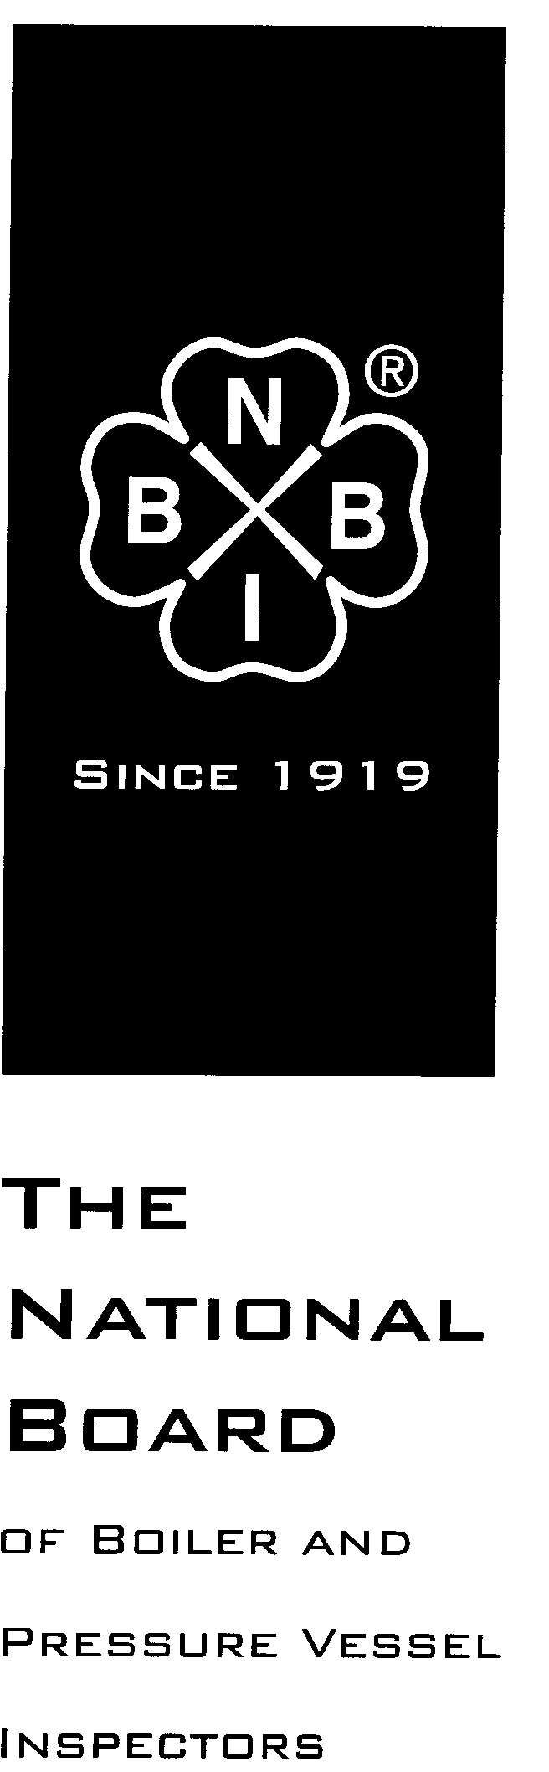

Date Distributed: January 9, 2017

NATIONAL BOARD
SUBGROUP
LOCOMOTIVE BOILERS

Minutes

Meeting of January 9th, 2017
San Diego, California

The National Board of Boiler & Pressure Vessel Inspectors
1055 Crupper Avenue
Columbus, Ohio 43229-1183
Phone: (614)888-8320
FAX: (614)847-1828

- Call to Order 10 AM

- Attendance of Members and Visitors (Attachment Page 4)

- Announcements

- The National Board invites all committee members and visitors to a reception at the Quad AleHouse on Wednesday, January 11th. The event begins at 5:30pm. The venue is approximately a five minute walk from the hotel.

- The draft of the 2017 edition of the NBIC has been approved by the NBIC Committee, and will be available for purchase on July 1st, 2017.

- Adoption of the Agenda adopted

- Approval of the Minutes of July 18th, 2016 Meeting

The minutes from the July 2016 meeting are approved
- Review of Rosters

  - Membership Nominations
  - Paul Welch currently on SC part 2 Inspection and NBIC Main Committee-general interest
  - Mark Jordan on current SG Historical presently- jurisdiction
  - Rick Musser assistant chief mechanical officer at Strasburg Railroad has attended past meetings-user
  - Charlie Cross Working for Durango and Silverton ( 12 years of locomotive experience)- user
  - All candidates passed
  - Membership Reappointments

There are no members of SG Locomotive eligible for reappointment to the subgroup.

- Action Items

Item Number: NB13-1401 | NBIC Location: Part 3, S1.9.2 | No Attachment
General Description: Add wording in this section regarding boiler tube welding
Subgroup: Locomotive

Task Group: R. Stone (PM)
History:

July 2014
A progress report given by Mr. Reetz. This item had not yet been considered by the SG locomotive boilers.

January 2015
Mr. Galanes gave a progress report. There was no action to report .

March 2015
This item unanimously passed SG Locomotive Boilers.

July 2015
This item was sent to letter ballot at the July 2015 meeting. This item failed a letter ballot to SC Repairs and Alterations due to five disapprovals (see attachment).

January 2016
Mr. Galanes reported that the subcommittee is awaiting comments from Mr. Stone.

July 2016
Progress report.- Mr. Stone received negatives and will address them.
January 2017
Progress Report- There was no action to report.

Item Number: NB13-1405 | NBIC Location: Part 3, S1.2.9 | Attachment 1
General Description: Add requirements for throttle pipes, dry pipes, superheater headers, and front end steam pipes
Subgroup: Locomotive

Task Group: R. Stone (PM)
History:

July 2014
Progress report given by Mr. Reetz. This item had not yet been considered by the SG locomotive boilers.

March 2015
This item was not worked on at the SG Locomotive Boilers meeting

July 2015
Mr. Galanes gave a progress report. No action was taken.

January 2016
Mr. Galanes reported that there was no progress made.

July 2016
Passed ballot of October 2013 will be forwarded to SC RA
January 2017
Motion to letter ballot was passed

Item Number: NB13-1407 | NBIC Location: Part 3, S1 | Attachment 2
General Description: Add requirements for repair and alteration of bolts, nuts, and studs in locomotive boilers
Subgroup: Locomotive

Task Group: R. Stone (PM)
History:

July 2014
A progress report given by Mr. Reetz. This item had passed SG locomotive boilers but did not make the SC R&A agenda.

January 2015
Mr. Galanes gave a progress report. There was no action to report.

March 2015
This item unanimously passed SG Locomotive Boilers.

July 2015
Mr. Galanes gave a progress report. A proposal was prepared by SG Locomotive Boilers. SC Repairs and Alterations sent this item to letter ballot at the July 2015 meeting. This item failed the letter ballot due to disapprovals.

January 2016
Mr. Galanes reported that there was no progress made.

July 2016
SC RA sent back to SG for action.
January 2017
Motion to letter ballot revised item was passed.

Item Number: NB13-1408 | NBIC Location: Part 3, S1 | No Attachment
General Description: Add requirements for repair and alteration of locomotive boilers with threaded boiler studs of the taper thread and straight thread varieties
Subgroup: Locomotive

Task Group: R. Stone (PM)

History:

July 2014
A progress report given by Mr. Reetz. This item had passed SG locomotive boilers but did not make the SC R&A agenda.

January 2015
Mr. Galanes gave a progress report. There was no action to report.

March 2015
This item unanimously passed SG Locomotive Boilers.

July 2015
Mr. Galanes gave a progress report. This item was sent back to SG Locomotive Boilers for further work.

January 2016
Mr. Galanes reported that there was no progress made.

July 2016
Mr. Galanes reported that there was no progress made.
Work to be done by R Stone and resubmitted to SG Locomotives
January 2017
Progress Report There was no action to report.

Item Number: NB16-1801 | NBIC Location: Part 3, S1 | No Attachment
General Description: Review Part 3 S1 for revisions based on the publication of ASME Section 1, Part PL
Subgroup: Locomotive

Task Group: L. Moedinger (PM)

July 2016
Progress report by L Moedinger
January 2017
Progress report by L Moedinger

Item Number: NB16-2501 | NBIC Location: Part 3, S1 | No Attachment
General Description: Change “radiographic” to “volumetric” to allow for ultrasonic
Subgroup: Locomotive

Task Group: L. Moedinger (PM)

July 2016
Progress report by L Moedinger
January 2017
This action is being done throughout the NBIC as an editorial change. Item is closed.

Item Number: NB16-2504 | NBIC Location: Part 3, S1 | Attachment 3
General Description: Evaluate adding SA-234 to the piping reference table S1.1.3.1
Subgroup: Locomotive

Task Group: D. Griner, M. Janssen

July 2016
Progress report by L Moedinger
January 2017
Motion to letter ballot passed

Errata- NBIC PART 3 Figure S1.2.11.5-f text was swapped on section A-A see attachment
- Future Meetings

July 17-20, 2017 – Columbus, Ohio
January 8-11, 2018 – Location TBD
- Adjournment
Respectfully submitted,
SG L Secretary
Robert Ferrell
Attachment 1
SG locomotives NB13-1405
NBIC Part 3 Paragraph(s): S1.2.14
Title: Throttle Pipes, Dry Pipes, Superheater Headers & Front End Steam Pipes
Date Opened: April 2013
Background:
The reason for adding this section is to provide guidance for repair of these locomotive boiler components. Two accidents have occurred to steam locomotives over the past 30 years when the dry pipe collapsed and caused the locomotive to operate out of control. Although neither accident caused injury equipment damage did occur. In addition other accidents that resulted in injury and fatalities have occurred to steam locomotives during the years of 1910 - 1950 when these were in normal railroad service.
Proposed Action: For letter ballot 9 January 2017
Throttle Pipes, Dry Pipes, Superheater Headers & Front End Steam Pipes
1) Throttle castings, dry pipes, super heater headers, and front end steam pipes may be repaired by brazing. Brazing shall be done according to a procedure appropriate to the type of repair and shall be acceptable to the Inspector and the jurisdiction if applicable. The completed repair shall not be subjected to operational stresses in excess of 5,000 psi (35 Mpa), nor repair mean temperatures greater than 550 F (290 C).
2) Cracks in throttle pipes, dry pipes, superheater headers, and front end steam pipes made from steel may be repaired by welding. All welded repairs shall be done in accordance with NBIC Part 3 and ASME Section I.
3) Weld build-up may be used for repair of steel components provided the corroded section does not exceed 10 square inches (64.52 square centimeters) in area and the depth of corrosion is less than 50% of the original wall thickness. If the corrosion depth or area exceeds one or both of these values, either the corroded section shall be replaced by a new section or the entire component replaced. Except as provided in this paragraph, all repairs shall be done in accordance with NBIC Part 3 and ASME Section I.
4) Throttle pipes, dry pipes and superheater headers, shall be supported by hangers, brackets or other structural method to prevent placing bending loads on the adjacent mating parts and attachment fasteners. Pins, bolts and nuts shall be prevented from loosening under service conditions.

Attachment 2

SG Locomotives National Board Item No. NB13-1407
Current Level: Subgroup letter Ballot
NBIC Part 3 Paragraph(s): S1.2.7.1 Title: Bolts, Nuts & Washers
Date Opened: April 2013
Background:
To provide guidance for the repair and replacement of the bolts, nuts and washers used on locomotive boilers for assembly of pressure retaining components.

Proposed Action: Item moved to letter ballot January 9, 2017

S1.2.7.1 Bolts, Nuts, & Washers
Bolts, nuts and washers used on locomotive boilers for assembly of pressure retaining components, shall be maintained, repaired or replaced in accordance with the directions of the original equipment manufacturer, if available. Bolts, nuts and washers that have wastage, corrosion or mechanical damage, sufficient to impair the holding power capability or function of the fastener shall be replaced, as permitted in NBIC Part 3, 3.3.3.

Note 1: Material requirements for bolts and nuts can be found in Table S1.1.3.1

Attachment 3 page 1 of 2
REVIEW of SA234
Linn,
Per your instructions we have reviewed the material Specification SA-234 and offer the following observations and recommendations.

- The title of the specification is;

SPECIFICATION FOR PIPING FITTINGS OF WROUGHT
CARBON STEEL AND ALLOY STEEL FOR MODERATE
AND HIGH-TEMPERATURE SERVICE

As can be seen it is directed at pipe fittings using various alloys.

- The specification lists 16 grades with Carbon contents varying from 0.05 thru 0.35, Manganese from 0.29 thru 1.06 and Molybdenum from 0.15 thru 1.13 depending on the grade selected.

- Tensile strengths from 60,000 psi thru 120,000 psi, again depending on the grade selected.

- Where grades WPB, WPC and WPR are used, the following requirements are applicable;

7.2.4 Cold-formed WPB, WPC, and WPR fittings,
upon which the final forming operation is completed at a
temperature below 1150°F [620°C], shall be normalized,
or shall be stress relieved at 1100 to 1275°F [595 to 690°C].

It appears the intent of this statement means forging cold,
However, it can easily be considered to apply to a final
machined part. These grades are those most likely to be used
in our work.

- This specification is for a finished product, not a “starting material” as noted by the following from paragraph 8.1 of the specification;

The ranges as shown have been expanded
to include variations of the chemical analysis requirements
that are listed in the various specifications for the starting
materials (pipe, tube, plate, bar, and forgings) normally
used in the manufacturing of fittings to this specification.

- From paragraph 6.1 of the specification;
Attachment 3 page 2 of 2

NOTE 1 — Fittings NPS 4 and under may be machined from hot-forged or rolled, cold-sized, and straightened bar stock having the chemical composition of the Grade in Table 1 and the mechanical properties of the Grade in Table 2. Heat treatment shall be in accordance with Section 7. All caps machined from bar stock shall be examined by liquid penetrant or magnetic particle in accordance with S52 or S53 in Specification A 960/A 960M.
This requirement can become rather onerous as reflected by trying to PT or MT a part that has threaded aspects to its geometry.

- This is a very complex specification not intended for providing raw materials to construct finished items.

- The large number of grades with corresponding significant variations in chemical and physical properties provide ample opportunity for misapplication, resulting in the possibility of serious construction/repair errors.

RECOMMENDATIONS
After thorough evaluation, specification SA 234 should only be assigned to our materials list where it is applicable to pipe fittings and then not in lieu of SA 105.

Respectfully submitted,

Dave Griner
Matt Janssen

Proposed Action: SA 234 will be assigned to the materials list in Table S1.1.3.1 when it applies to pipe fittings.

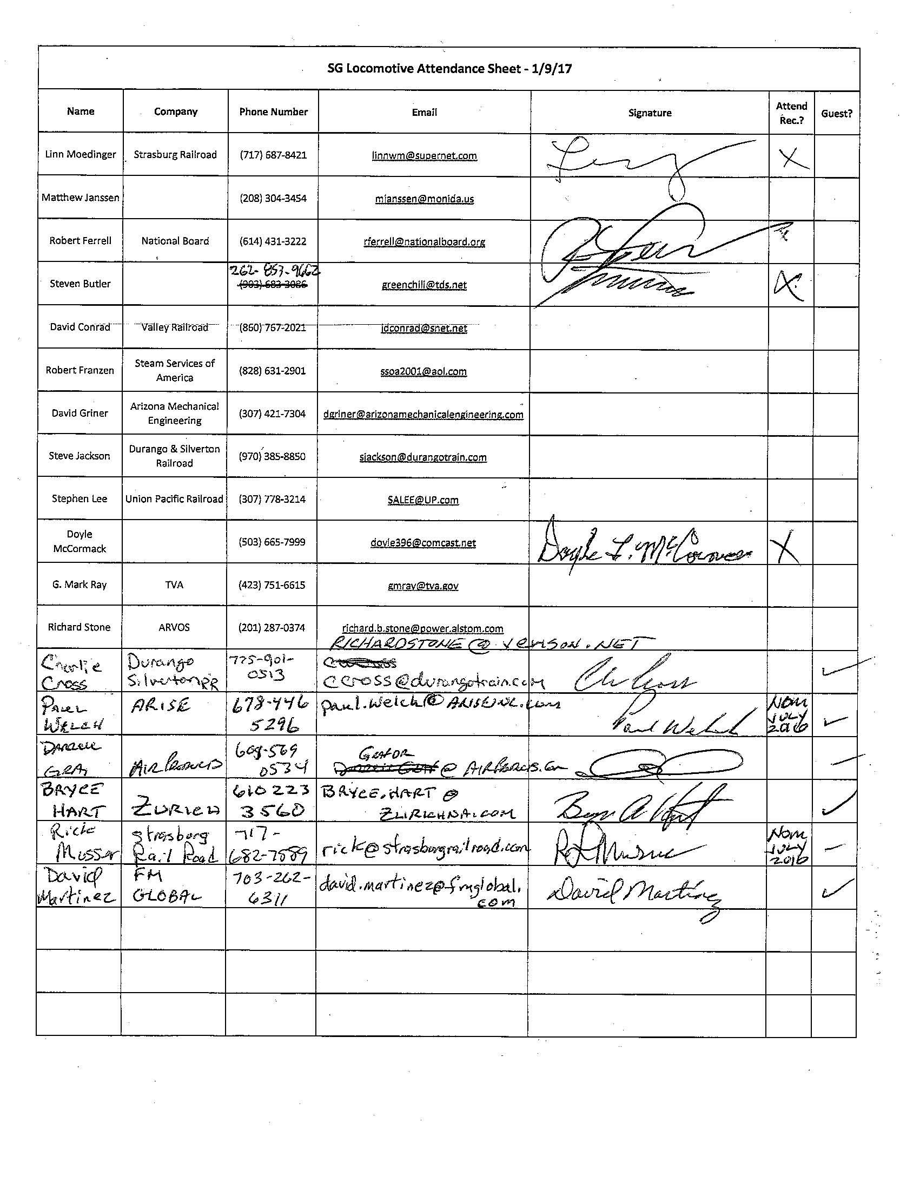
Attachment 4

