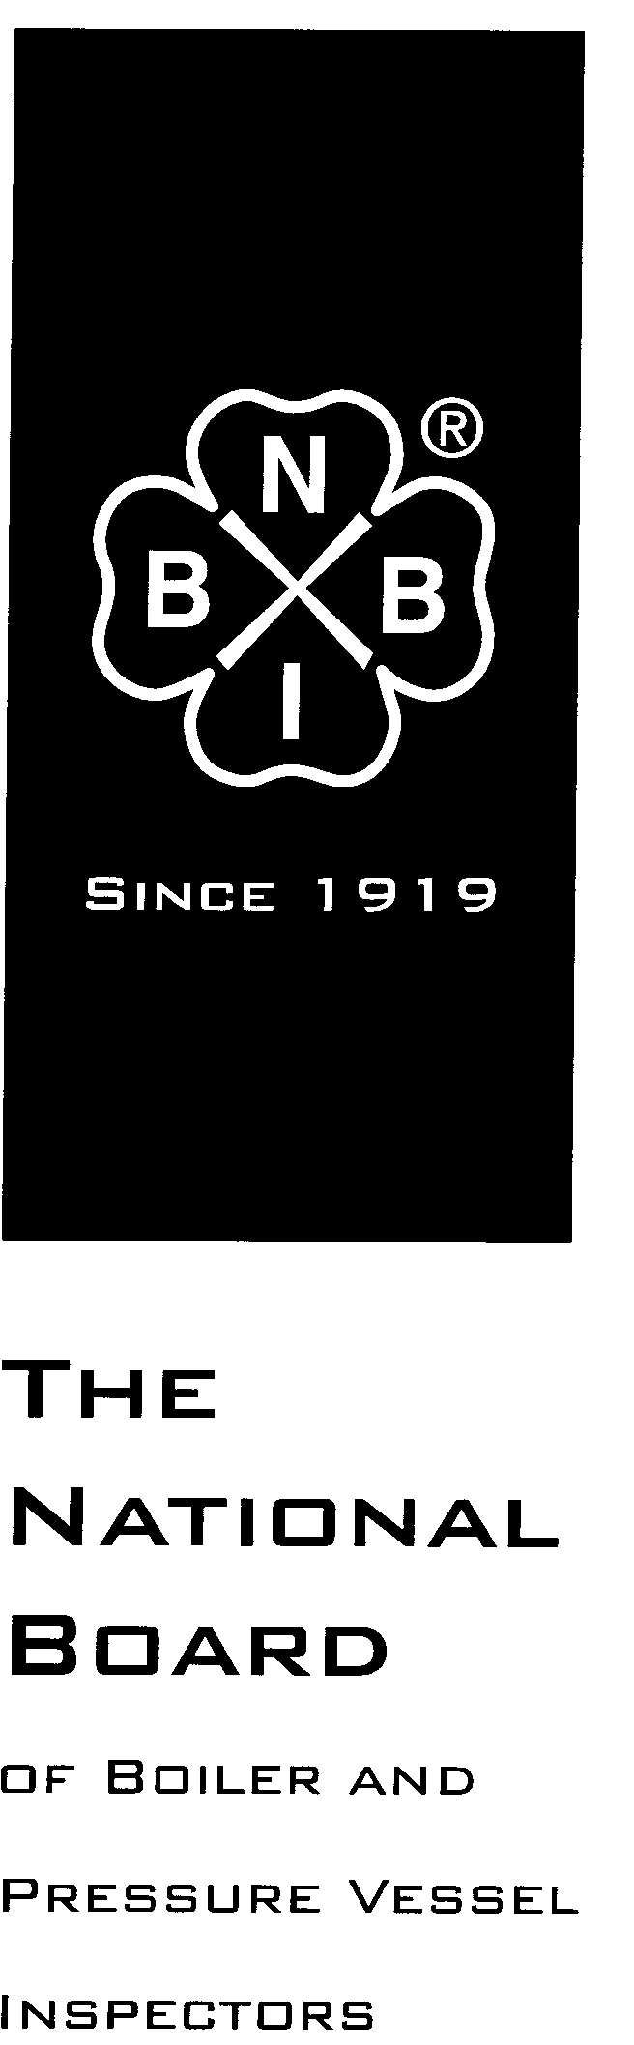

Date Distributed: July 19, 2017

NATIONAL BOARD
SUBGROUP
LOCOMOTIVE BOILERS

MINUTES

Meeting of July 17th, 2017
Columbus, Ohio

The National Board of Boiler & Pressure Vessel Inspectors
1055 Crupper Avenue
Columbus, Ohio 43229-1183
Phone: (614)888-8320
FAX: (614)847-1828

- Call to Order 925 AM

- Introduction of Members and Visitors (Attachment Page 1)

- Announcements
The National Board invites all committee members and visitors to a reception at the Pavilion next to the pond between 5-5:30pm Wednesday
Breakfast and lunch provided to NBIC Committee members on Thursday
NBIC meeting will run all day on Thursday- until 5:00pm
- Adoption of the Agenda
  - Agenda adopted unanimously
- Approval of the Minutes of January 9th, 2017 Meeting
Minutes approved
The minutes of the July, 2017 meeting are published on the National Board website, www.nationalboard.org.

- Review of Rosters

  - Membership Appointments

There are no members eligible for reappointment to SG Locomotive.

- NBIC Business

- Interpretations

Item Number: 17-143 | NBIC Location: Part 3 3.2.2 | Attachment Page 5
General Description: An R certificate holder wants to manufacture a sub assembly and use it on a power boiler.
Subgroup: Locomotive

Task Group: P Welch PM
July 2017 Item discussed. Mr. Welch will supply wording for the reply which will be letter balloted to this sub-group following the July 2017 meeting.

- Action Items – Old Business

Item Number: 13-1401 | NBIC Location: Part 3, S1.9.2 | No Attachment
General Description: Add wording in this section regarding boiler tube welding
Subgroup: Locomotive

Task Group: R. Stone (PM)
January 2017: No action was taken on this item.
July 2017: No action was taken on this item. PM will review ballot comments from R&A and comments will be provided on NBIC Share.org for SG Locomotive review.

Item Number: 13-1405 | NBIC Location: Part 3, S1.2.9 | No Attachment
General Description: Add requirements for throttle pipes, dry pipes, superheater headers, and front end steam pipes
Subgroup: Locomotive

Task Group: R. Stone (PM)
January 2017: The item was sent to SG Locomotive letter ballot after the January 2017 meeting. It received two negative votes during balloting. The ballot was withdrawn for further work.
July 2017 Closed

Item Number: 13-1407 | NBIC Location: Part 3, S1 | No Attachment
General Description: Add requirements for repair and alteration of bolts, nuts, and studs in locomotive boilers
Subgroup: Locomotive

Task Group: R. Stone (PM)
January 2017: The item was sent to SG Locomotive letter ballot after the January 2017 meeting. It received one negative vote and one abstention during balloting. The ballot was withdrawn for further work.
July 2017: Closed

Item Number: 13-1408 | NBIC Location: Part 3, S1 | Attachment Pages 7-11
General Description: Add requirements for repair and alteration of locomotive boilers with threaded boiler studs of the taper thread and straight thread varieties
Subgroup: Locomotive

Task Group: R. Stone (PM)
January 2017: No action was taken on this item.
July 2017:reaffirmed as changed 1 negative , and 5 approved; Moved to letter ballot 19 July 2017 at Sub-committee Repairs & Alterations

Item Number: 16-1801 | NBIC Location: Part 3, S1 | No Attachment
General Description: Review Part 3 S1 for revisions based on the publication of ASME Section 1, Part PL
Subgroup: Locomotive

Task Group: L. Moedinger (PM)

January 2017: No action was taken on this item.

Item Number: NB16-2504 | NBIC Location: Part 3, S1 | No Attachment
General Description: Evaluate adding SA-234 to the piping reference table S1.1.3.1
Subgroup: Locomotive

Task Group: D. Griner, M. Janssen

January 2017: This item was sent to SG Locomotive letter ballot after the January 2017 meeting and received one negative vote. The ballot was withdrawn for further work.
July 2017: Progress report

Item Number: 17-145 | NBIC Location: Part 3, S1.2.2-S1.25 | No Attachment
General Description: Clarify repair vs. alteration for locomotive boilers
Subgroup: Locomotive

Task Group: PM L Moedinger.
New items:
Item Number: 17-155 | NBIC Location: Part 3, S1.2.14 | Attachment Page 6
General Description: Throttle pipes, dry pipes, superheater headers, and front end steam pipes
Subgroup: Locomotive

Task Group: PM R. Stone
July 2017: Passed for a letter ballot to SG Locomotives

Item Number: 17-156 | NBIC Location: Part 3, S1.1.2 | No Attachment
General Description: Requirements for Welding and Brazing Activities
Subgroup: Locomotive

Task Group: PM G.M Ray

Item Number: 17-157 | NBIC Location: Part 3, S1.2.7.1 | Attachment Page 12
General Description: Bolts Nuts and Washers
Subgroup: Locomotive

Task Group: PM R. Stone
July 2017: Passed and moved to letter ballot at SCRA

Item Number: 17-160 | NBIC Location: Part 3, S1 | Attachment Page 13
General Description: Partial Knuckle replacement riveted to welded
Subgroup: Locomotive

Task Group: PM R. Frazen

- Future Meetings
- January 8th-11th, 2018 – New Orleans, Louisiana
- July 16th-19th, 2018 – Columbus, Ohio
- Adjournment

Respectfully submitted,

Robert Ferrell
SG Locomotives Secretary

The Sub Groups response: Can an "R" stamp certificate holder manufacture and use parts or sub-assemblies for use as part of the pressure boundary in the repair of a power boiler? YES
To: Allan Bornhorst,QC Supervisor
Geotech Industries
From: NBIC Committee
The committee feels that providing any more information on your method of repair would be providing consulting services which is against NBIC committee protocol.

17-155
NBIC Part 3 Paragraph(s): S1.2.14
Title: Throttle Pipes, Dry Pipes, Superheater Headers & Front End Steam Pipes
Date Opened: July 17, 2017 (reworked from NB13-1405)
Background:
The reason for adding this section is to provide guidance for repair of these locomotive boiler components. Two accidents have occurred to steam locomotives over the past 30 years when the dry pipe collapsed and caused the locomotive to operate out of control. Although neither accident caused injury equipment damage did occur. In addition other accidents that resulted in injury and fatalities have occurred to steam locomotives during the years of 1910 - 1950 when these were in normal railroad service.
Proposed Action: New Paragraph For letter ballot after July 2017
S1.2.14 Throttle Pipes, Dry Pipes, Superheater Headers & Front End Steam Pipes
1) Cracks in throttle pipes, dry pipes, superheater headers, and front end steam pipes made from steel may be repaired by welding. All welded repairs shall be done in accordance with NBIC Part 3.
2) Throttle castings, dry pipes, super heater headers, and front end steam pipes constructed of cast iron may be repaired by brazing. Brazing shall be done according to a procedure qualified to ASME Section IX, appropriate to the type of repair, and shall be acceptable to the Inspector and the jurisdiction if applicable. Cast iron shall not be fusion welded.
3) Weld build-up may be used for repair of steel components in accordance with NBIC Part 3.
4) Throttle pipes, dry pipes and superheater headers, should be supported by hangers, brackets or other structural methods as needed.

NB13-1408
NBIC Part 3 S1.2.7.2 Patch Bolts S1.2.7.3 from S1.2.8

Revised title and section: S1.2.7.2 TAPER THREAD BOILER STUDS (SEE NBIC PART 3, FIGURES
S1.2.7.2-a, S1.2.7.2-b & S1.2.7.2-c)

Taper thread boiler studs are designed to thread directly into the boiler shell and are used to secure locomotive boiler components or related locomotive components such as pipe brackets for boiler piping, dome cover and feed water check valves. The stud end that threads into the boiler shell is machined with a boiler-type taper thread and the mating hole in the boiler shell is tapped with the same boiler-type taper thread. The opposite end of the stud is machined with standard straight machine screw-type threads to permit attachment of the components along with a nut and washer.

Taper thread boiler studs used on locomotive boilers shall be maintained, repaired or replaced in accordance with the directions of the original equipment manufacturer. If this information is not available, the following procedures shall be used.

- Taper thread boiler studs and the mating tapped holes shall be made to the required size and taper to create a tight and leak free joint upon final tightening. The stud taper threads shall have a good uniform fit along the entire length of the tapped hole threads and not just at the top or bottom edges of either the stud or hole. When the hole threads are to be tapped in new material or re-tapped for repair or cleaning the taper tap shall be run through the entire hole depth in order to form all threads correctly. The length of the taper thread section shall be sized so that upon the stud being tightened at final assembly at least one full thread shall be above the boiler shell exterior surface and no less than flush with the interior surface. (See Fig.S1.2.7.2-c)

- When taper thread boiler studs are installed into blind holes on the boiler shell or sheet the taper section length shall be confirmed to be shorter than the hole depth in order to prevent the stud from contacting the hole bottom upon being tightened at final assembly.

- Studs and boiler shell surfaces that are cracked or damaged shall be either repaired or replaced per items “f” and “g” of this section.

- Changes to the taper, thread pitch or thread form of the taper thread boiler stud or its mating tapped hole in the boiler shall be suitable for the service intended.

- Replacement taper thread boiler studs of a different strength, grade specification or size than the original shall be suitable for the service intended.

- A worn or damaged taper thread stud hole may be repaired by re-tapping it to a larger diameter and installing a taper thread boiler stud that has a corresponding larger diameter boiler thread end than the original stud. The largest portion of the tapered section of the stud shall not exceed the original stud straight section (shank) diameter by 33%. The larger diameter boiler stud shall be made with a 1/8 inch (3mm) radius from the stud body into the larger diameter boiler thread end.

- Oversize cracked or damaged boiler studs holes in the boiler shell may be repaired by weld build-up or by replacing the damaged plate section using a flush patch. If weld build-up is performed, the existing boiler stud threads shall be removed from the hole by reaming, grinding or machining prior to welding. All welding and welded repairs shall be performed per NBIC Part 3.

  - Taper thread boiler studs, nuts and washers that have wastage, corrosion or mechanical damage, sufficient to impair the holding power or function of the fastener shall be replaced.

  - Taper thread boiler studs and nuts that have damaged threads may be repaired by re-threading.

  - Replacement taper thread boiler studs, nuts and washers shall have the same fitup, alignment and thread engagement length as the original.

  - The use of replacement taper thread boiler studs, nuts and washers of a different strength, grade specification or size than the original shall be suitable for the service intended.

Notes: If a taper thread boiler stud or nut is heated to a metal temperature that exceeds 1100°F (593°C), it will be damaged or suffer a reduction of hardness and should be replaced.

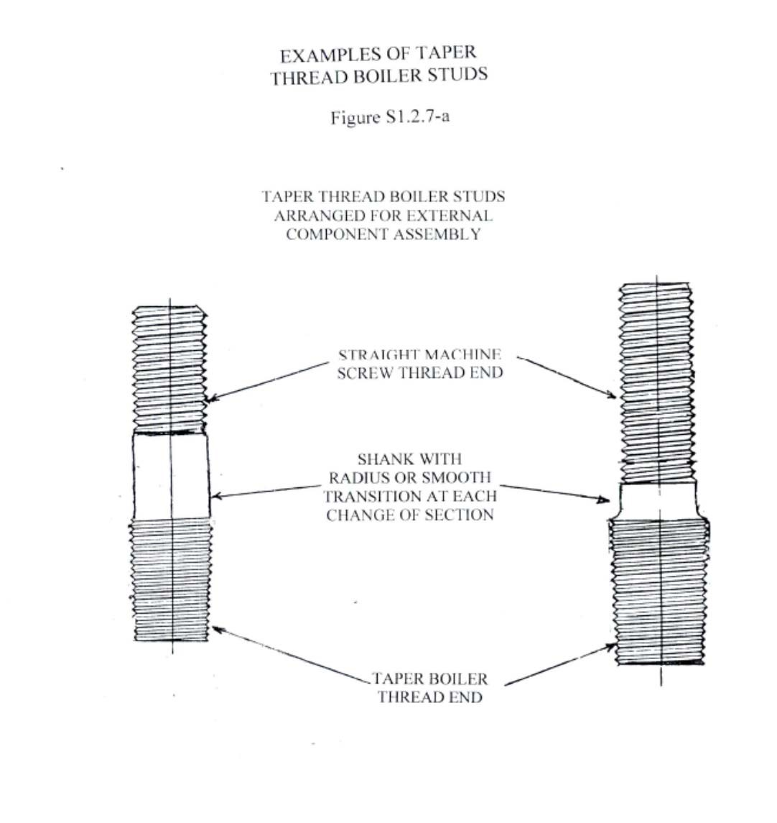

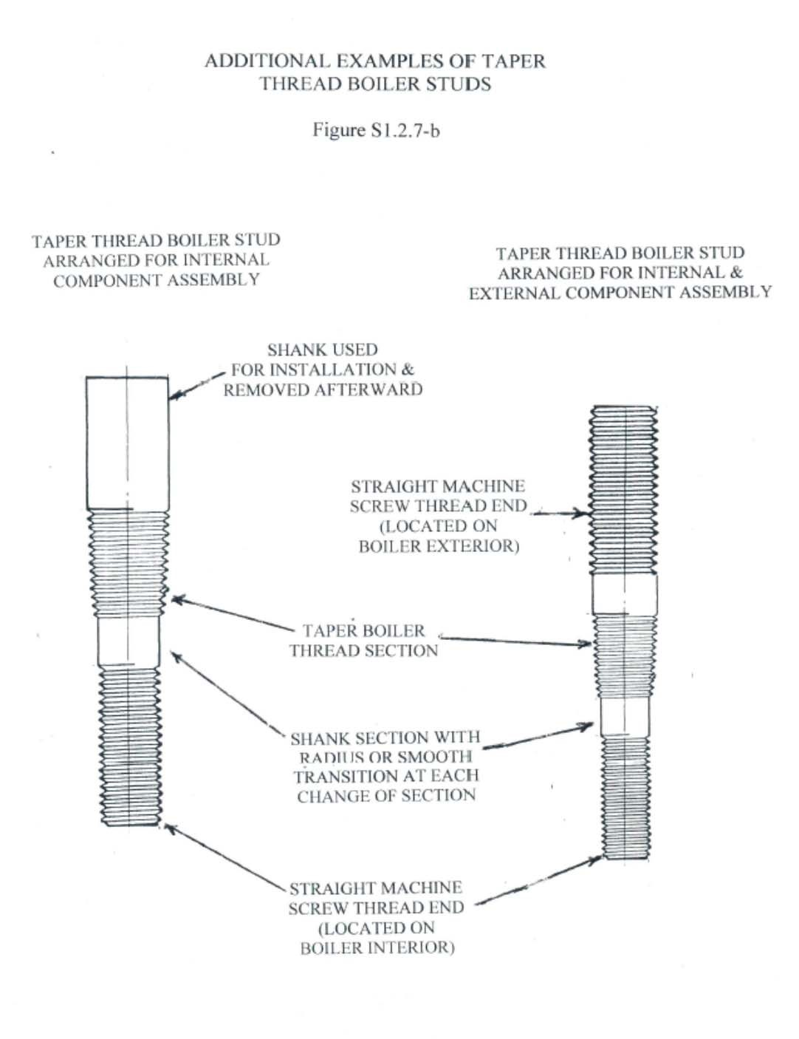

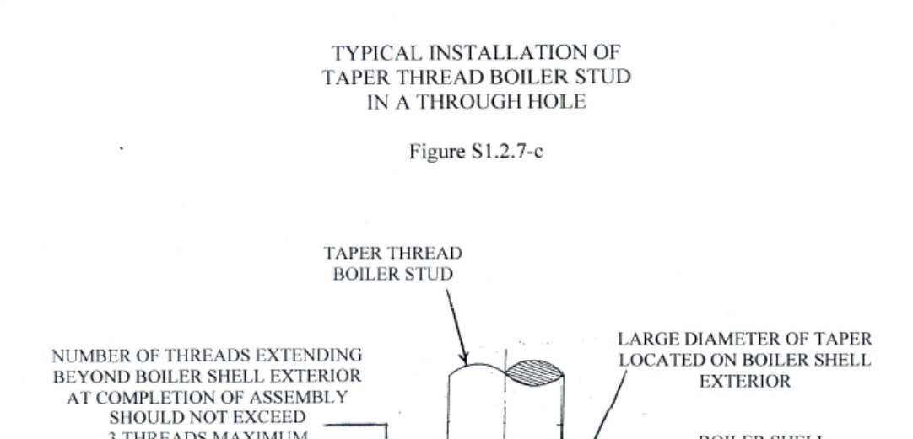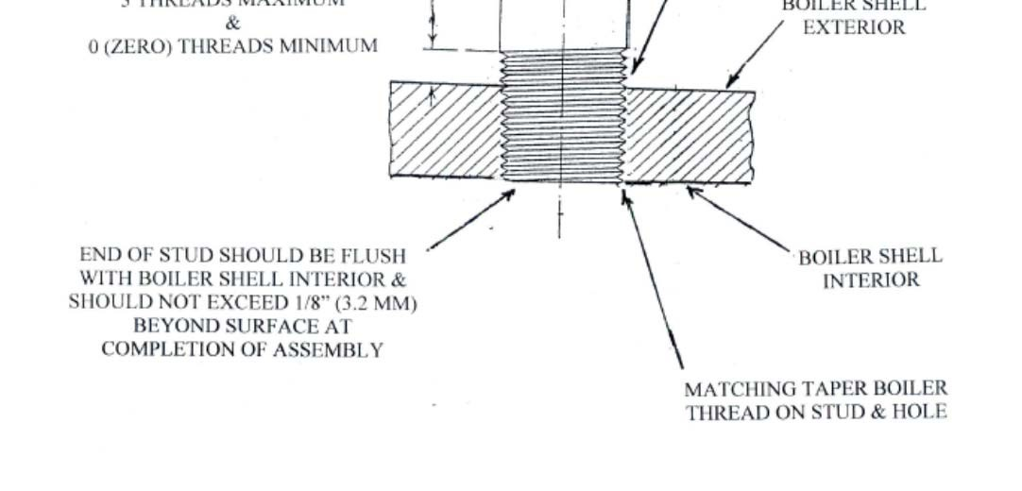

1(

Subgroup Locomotives National Board Item No. 17-157
Current Level: Subgroup discussion
NBIC Part 3 Paragraph(s): S1.2.7.1 Title: Bolts, Nuts & Washers
Date Opened: April 2013
Background:
To provide guidance for the repair and replacement of the bolts, nuts and washers used on locomotive boilers for assembly of pressure retaining components.

Proposed Action: Item moved to letter ballot to SG locomotives July 17, 2017

S1.2.7.1 Bolts, Nuts, & Washers
Bolts, nuts, and washers that have wastage, corrosion, or mechanical damage, sufficient to impair the holding power capability or function of the fastener shall be replaced, as permitted in NBIC Part 3, 3.3.3.
Upon disassembly, bolts and nuts that have been tack welded shall not be re-used.

Note 1: Material requirements can be found in Table S1.1.3.1

17-160 Replace portion of firebox knuckle from riveted to welded

SG Locomotive Discussion Points Franzen 7-12-17

1. Replacing a portion of a flanged riveted knuckle lap joint in the inner firebox area including corner patches to a one piece flanged welded joint. Example: Top knuckle of the riveted rear flue sheet or partial patches in any area of the riveted joint of the rear flue sheet or riveted door sheet with a one piece flanged welded joint. The one piece welded knuckle would encompass either one row of staybolts and /or one row of tubes. The problem area is the welded joint at the riveted lap seam to the one piece patch. Reference S1.2.11.2 (c), S1.2.11.5, and Figure S1.2.11.5-c. Why would this repair not be acceptable????? Either way, acceptable or not, this needs to be added in the sections above.

2. Is a welded lap knuckle joint that is welded on both sides of the lap joint in the inner firebox area acceptable or not acceptable. Either way it needs to be noted in Section S1.2.11.5 and Figure S1.2.11.5-c. ASME Code says it is not acceptable if the joint is exposed to products of combustion and is acceptable if not exposed to products of combustion.

3. Is welded lap joint in the firebox knuckle area only welded on one side (fireside or waterside) of the lap joint acceptable? Or is a welded lap joint welded on both sides of the lap joint in the top knuckle and around the radius of the top knuckle and welded only on the fireside of the lap joint from the bottom of the knuckle radius down to the mud ring acceptable? If it is acceptable or not acceptable it needs to be stated in Sections S1.2.11.5 and Figure S1.2.11.5-c.

