Subject: Part 2, Supplement 2,
S2.10.4 – Stayed Surfaces

File Number: NB11-0201

Proposal:
Introduce a new section to provide guidance for bulged stayed surfaces to address requests for guidance from various jurisdictions. Proposed wording is as follows:

S2.10.4.2 BULGING
Stayed surfaces shall be examined, and any deformations shall be measured and recorded. Deformations may be caused from freezing, localized overheating, broken staybolts, or extended use (cyclic activity). Deformations may be described as bulging, bagging, or pillow/mattress-effects. The bulged section depth is defined as the protrusion of the sheet beyond its original position.

      - Changes in deformations between inspections shall be noted and shall require additional evaluation to determine fitness for service.

      - The probable cause of the deformation shall be determined and, where possible, resolved. For example, overheating due to scale build-up requires removal of scale.

      - The amount of the bulging shall be measured:
        - If the depth of the bulge does not exceed 50% of plate thickness, then no further activity is required.
        - If the depth of the bulge is between 50% and 100% plate thickness, and thread engagement is not affected, then additional NDE is required.
    - Note: If ultrasonic thickness testing (S2.6.2.c) is performed, then it is performed on a tight (1-inch) grid to determine any thinning throughout the deformation. Any generalized thinning (S2.6.2.b) shall be used in the calculation of MAWP.
        - If the depth of the bulge exceeds the thickness of the plate, then repair is required.

      - The location of the deformations shall be examined. If the point of tangency of the curve in a bulge is within ‘t’ of the edge of the staybolt head , then determination of thread engagement shall be made. (‘t’ is defined in S2.10.6, and is the thickness of the plate.) Removal of one or more staybolts may be required to make this determination. Refer to Figure S2.10.4.2.d.
        - Cracks, deformations, and/or missing portions of the threaded staybolt head may indicate a deformation of the plate at the staybolt.

Figure S2.10.4.2.d
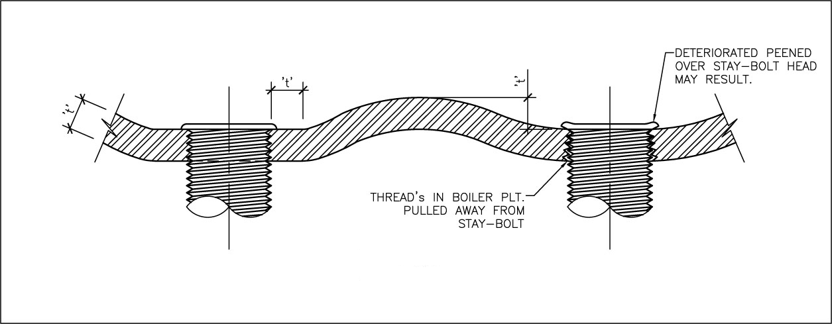

      - The following guidelines apply where repair is required.
        - Plate may only be repaired using a flush patch, in accordance with Supplement 2 of Part 3.
        - Where a deformation is to be repaired, all portions of that deformity shall be repaired. For example, for contiguous bulging where only some bulges exceed allowable deformation, the entire bulged area shall be repaired. Unrelated bulges separated by non-deformed plate shall be independently evaluated.

FIGURE OF BULGED STAYED AREA
