Subject: 2007 Edition, Part 3, Supplement 2, S2.13.9.2 – Welded Repair of Cracks in Unstayed Area
File Number: NB10-0103
Prop. Page: 156 & 157
Proposal: Update figure S2.13.9.2 to show crack in non-riveted area, update text to fix a typo, move “See figure S.2.13.9.2” and change girth to circumferential.
Explanation This area currently is confusing and can be updated and corrected to fix these issues. There are six issues to address.
- Remove “See figure S.2.13.9.2” from a).
- Correct Typo in b) should say Cracks in unstayed not Cracks in stayed
- Change 8” requirement to insure that the repair is at least 2” from last row of rivets and that preheat is used. Text should be changed to “within 2in. (50mm) from the center line of the outer most row of rivets. Minimum 175 degree preheat shall be used.”
- Add a reference to figure S2.13.9.2-a in c).
- Add a reference to figure S2.13.9.2 –b in d).
- Change girth to circumferential in d)
- Use new figure S.2.13.9.2-a and S.13.9.2-b

Update text and diagram can be found on page 3
Item # 4
Change to UNSTAYED
Replace this Figure with one on page 3

Item # 3
Change text for 8” rule and preheat
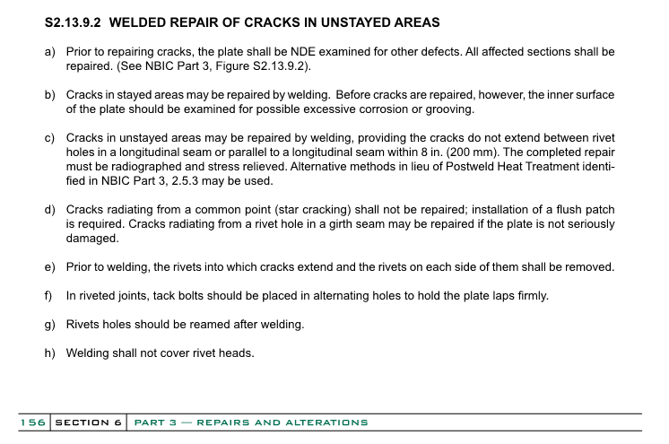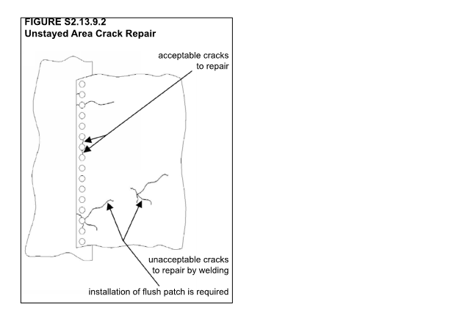
Updated text and Diagram
Item # 7 Replace this with the Figure S2.13.9.2-a and Figure S2.13.9.2-b on page 3
Item # 2
Add Reference to Figure
(See Figure S2.13.9.2.)
Item # 5 Replace this with the Figure S2.13.9.2 and S.2.13.9.2a on page 3
Item # 6
Change girth to Circumferential
Item # 2
Change to UNSTAYED
Item # 1
Remove text from here
(See Figure S2.13.9.2.-a)
Item # 4
Add Reference to Figure
(See Figure S2.13.9.2-b)
Item # 5
Add Reference to Figure
Girth Seam
S.2.13.9.2 WELDED REPAIR OF CRACKS IN UNSTAYED AREAS
- Prior to repairing cracks, the plate shall be NDE examined for other defects. All affected sections shall be repaired.
- Cracks in unstayed areas may be repaired by welding. Before cracks are repaired, however, the inner surface of the plate should be examined for possible excessive corrosion or grooving.
- Cracks in unstayed areas may be repaired by welding, providing the cracks do not extend between rivet holes in a longitudinal seam or parallel to a longitudinal seam within 2in. (50mm) from the center line of the outer most row of rivets. Minimum 175⁰ F. (65⁰ C.) preheat shall be used. The complete repair must be radiographed and stress relieved. Alternative methods in lieu of Postweld Heat Treatment identified in NBIC Part 3, 2.5.3 may be used. (See NBIC Part 3, Figure S.2.13.9.2-a)
- Cracks radiating from a common point (star cracking) shall not be repaired; installation of a flush patch is required. Cracks radiating from a rivet hole in a circumferential seam may be repaired if the plate is not seriously damaged. (See NBIC Part 3, Figure S.2.13.9.2-b)
- Prior to welding, the rivets into which cracks intend and the rivets on each side of them shall be removed.
- In riveted joints, tack bolts should be placed in alternating holes to hold plate laps firmly.
- Rivets holes should be reamed after welding.
- Welding shall not cover rivet heads.
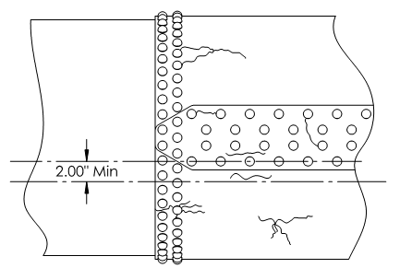
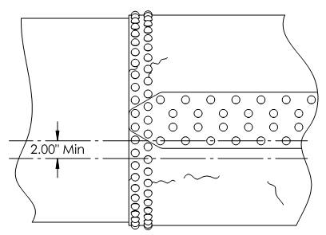
Figure S2.13.9.2-b
Unstayed Area Crack Repair
Figure S2.13.9.2-a
Unstayed Area Crack Repair
Cracks Acceptable to Repair by Welding
Cracks Unacceptable to Repair by Welding

