Subject: Part 2, Supplement 2, S2.10.4 – Average Staybolt Pitch
Attachment 4
File Number: NB12-1201
Proposal: Update text in S2.10.4, S2.10.6 to include provisions and mathematics for rectangular staybolt patterns found on many historical boilers.
Current text:
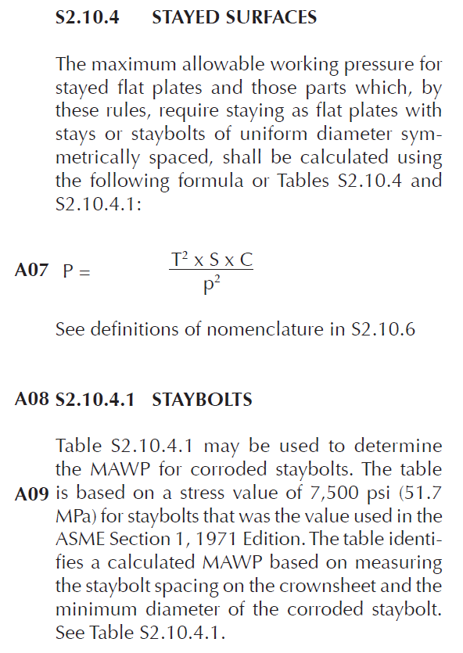
Reword as follows:
S2.10.4 STAYED SURFACES
The maximum allowable working pressure for stayed flat plates and those parts which, by these rules, require staying as flat plates with stays or staybolts of uniform diameter, uniformly spaced, shall be calculated using the following formula or Table S2.10.4.
$$P=\frac{t^{2}×S×C}{p^{2}}$$
When pitches of stays or staybolts of uniform diameter are symmetrical and form a rectangle, the equation may be replaced with the following equation:
$$P=\frac{{2×t}^{2}×S×C}{l^{2}+w^{2}}$$
See definitions of nomenclature in S2.10.6.
[…]
S2.10.6 NOMENCLATURE
[…]
- p = maximum pitch measured between straight lines passing through the centers of the staybolts in the different rows, which lines may be horizontal, vertical, or inclined, inches or mm
- l = the pitch of stays in one row, passing through the centers of the staybolts, which line may be horizontal, vertical, or inclined, inches or mm
- w = the distance between two rows of staybolts, inches or mm
- h = the hypotenuse of a square or rectangle, defined as either $\sqrt{2p^{2}}$ or $\sqrt{l^{2}+w^{2}}$, inches or mm
- d = minimum diameter of corroded staybolt, inches or mm

[…]

p
Thickness of Stayed Surface, in. |  | Staybolt Spacing (Square Pitch), in. (p)
 |  | 3.500 | 3.625 | 3.750 | 3.875 | 4.000 | 4.125 | 4.250 | 4.375 |  | 4.500 | 4.625 | 4.750 | 4.875 | 5.000 |  | 5.125 | 5.250 | 5.375 | 5.500 | 5.625 | 5.750 | 5.875 | 6.000
0.19 |  | 85 | 80 | 74 | 70 | 65 | 61 | 58 | 55 |  | 52 | 49 | 46 | 44 | 42 |  | 40 | 38 | 36 | 35 | 33 | 32 | 30 | 29
0.2 |  | 95 | 88 | 82 | 77 | 72 | 68 | 64 | 61 |  | 57 | 54 | 51 | 49 | 46 |  | 44 | 42 | 40 | 38 | 37 | 35 | 34 | 32
0.21 |  | 104 | 97 | 91 | 85 | 80 | 75 | 71 | 67 |  | 63 | 60 | 57 | 54 | 51 |  | 49 | 46 | 44 | 42 | 40 | 39 | 37 | 36
0.22 |  | 115 | 107 | 100 | 93 | 88 | 82 | 78 | 73 |  | 69 | 66 | 62 | 59 | 56 |  | 53 | 51 | 49 | 46 | 44 | 42 | 41 | 39
0.23 |  | 125 | 117 | 109 | 102 | 96 | 90 | 85 | 80 |  | 76 | 72 | 68 | 65 | 61 |  | 58 | 56 | 53 | 51 | 48 | 46 | 44 | 43
0.24 |  | 136 | 127 | 119 | 111 | 104 | 98 | 92 | 87 |  | 82 | 78 | 74 | 70 | 67 |  | 64 | 61 | 58 | 55 | 53 | 50 | 48 | 46
0.25 |  | 148 | 138 | 129 | 121 | 113 | 106 | 100 | 95 |  | 89 | 85 | 80 | 76 | 72 |  | 69 | 66 | 63 | 60 | 57 | 55 | 52 | 50
0.26 |  | 160 | 149 | 139 | 130 | 122 | 115 | 108 | 102 |  | 97 | 92 | 87 | 82 | 78 |  | 75 | 71 | 68 | 65 | 62 | 59 | 57 | 54
0.27 |  | 172 | 161 | 150 | 141 | 132 | 124 | 117 | 110 |  | 104 | 99 | 94 | 89 | 85 |  | 80 | 77 | 73 | 70 | 67 | 64 | 61 | 59
0.28 |  | 185 | 173 | 162 | 151 | 142 | 134 | 126 | 119 |  | 112 | 106 | 101 | 96 | 91 |  | 87 | 82 | 79 | 75 | 72 | 69 | 66 | 63
0.29 |  | 199 | 185 | 173 | 162 | 152 | 143 | 135 | 127 |  | 120 | 114 | 108 | 103 | 97 |  | 93 | 88 | 84 | 81 | 77 | 74 | 71 | 68
0.3 |  | 213 | 198 | 185 | 174 | 163 | 153 | 144 | 136 |  | 129 | 122 | 116 | 110 | 104 |  | 99 | 95 | 90 | 86 | 82 | 79 | 76 | 72
0.31 |  | 227 | 212 | 198 | 185 | 174 | 164 | 154 | 146 |  | 138 | 130 | 123 | 117 | 111 |  | 106 | 101 | 96 | 92 | 88 | 84 | 81 | 77
0.32 |  | 242 | 226 | 211 | 198 | 185 | 174 | 164 | 155 |  | 147 | 139 | 132 | 125 | 119 |  | 113 | 108 | 103 | 98 | 94 | 90 | 86 | 82
0.33 |  | 258 | 240 | 224 | 210 | 197 | 185 | 175 | 165 |  | 156 | 148 | 140 | 133 | 126 |  | 120 | 115 | 109 | 104 | 100 | 95 | 91 | 88
0.34 |  | 273 | 255 | 238 | 223 | 209 | 197 | 185 | 175 |  | 165 | 157 | 148 | 141 | 134 |  | 128 | 122 | 116 | 111 | 106 | 101 | 97 | 93
0.35 |  | 290 | 270 | 252 | 236 | 222 | 209 | 197 | 185 |  | 175 | 166 | 157 | 149 | 142 |  | 135 | 129 | 123 | 117 | 112 | 107 | 103 | 99
0.36 |  | 307 | 286 | 267 | 250 | 235 | 221 | 208 | 196 |  | 185 | 176 | 166 | 158 | 150 |  | 143 | 136 | 130 | 124 | 119 | 114 | 109 | 104
0.37 |  | 324 | 302 | 282 | 264 | 248 | 233 | 220 | 207 |  | 196 | 185 | 176 | 167 | 159 |  | 151 | 144 | 137 | 131 | 125 | 120 | 115 | 110
0.38 |  | 342 | 318 | 298 | 279 | 262 | 246 | 232 | 219 |  | 207 | 196 | 185 | 176 | 167 |  | 159 | 152 | 145 | 138 | 132 | 127 | 121 | 116
0.39 |  | 360 | 335 | 313 | 294 | 275 | 259 | 244 | 230 |  | 218 | 206 | 195 | 185 | 176 |  | 168 | 160 | 153 | 146 | 139 | 133 | 128 | 122
0.4 |  | 379 | 353 | 330 | 309 | 290 | 273 | 257 | 242 |  | 229 | 217 | 206 | 195 | 185 |  | 177 | 168 | 160 | 153 | 147 | 140 | 134 | 129
0.41 |  | 398 | 371 | 346 | 324 | 304 | 286 | 270 | 255 |  | 241 | 228 | 216 | 205 | 195 |  | 185 | 177 | 169 | 161 | 154 | 147 | 141 | 135
0.42 |  | 417 | 389 | 364 | 340 | 320 | 300 | 283 | 267 |  | 252 | 239 | 227 | 215 | 204 |  | 195 | 185 | 177 | 169 | 162 | 155 | 148 | 142
0.43 |  | 437 | 408 | 381 | 357 | 335 | 315 | 297 | 280 |  | 265 | 251 | 237 | 225 | 214 |  | 204 | 194 | 185 | 177 | 169 | 162 | 155 | 149
0.44 |  | 480 | 447 | 418 | 391 | 367 | 345 | 325 | 307 |  | 290 | 275 | 261 | 247 | 235 |  | 224 | 213 | 203 | 194 | 186 | 178 | 170 | 163
0.45 |  | 502 | 468 | 437 | 409 | 384 | 361 | 340 | 321 |  | 304 | 287 | 272 | 259 | 246 |  | 234 | 223 | 213 | 203 | 194 | 186 | 178 | 171
0.46 |  | 524 | 489 | 457 | 428 | 402 | 378 | 356 | 336 |  | 317 | 300 | 285 | 270 | 257 |  | 245 | 233 | 222 | 212 | 203 | 194 | 186 | 178
0.47 |  | 547 | 510 | 477 | 447 | 419 | 394 | 371 | 350 |  | 331 | 314 | 297 | 282 | 268 |  | 255 | 243 | 232 | 222 | 212 | 203 | 194 | 186
0.48 |  | 571 | 532 | 497 | 466 | 437 | 411 | 387 | 365 |  | 345 | 327 | 310 | 294 | 280 |  | 266 | 254 | 242 | 231 | 221 | 212 | 203 | 194
 | TS = Tensile Strength, 55,000 psi  S = 13,800 psi  t = Thickness of Stayed Surface, in.  p = staybolt spacing, in. |  |  |  |  |  |  |  |  | $$P=\frac{t^{2}×S×C}{p^{2}}$$ |  |  |  |  |  | For thicknesses 0.4375” and less, C = 2.1  For thicknesses larger than 0.4375”, C = 2.2  P = MAWP, psi
Table S2.10.4 [US Customary Units]
Maximum Allowable Working Pressure for Square Stayed Surfaces, Formula per ASME Section 1, PG-46.1
p

Thickness of Stayed Surface, mm |  | Staybolt Spacing (Square Pitch), mm (p)
 |  | 89 | 92 | 95 | 98 | 101 | 104 | 107 | 110 |  | 113 | 116 | 119 | 122 | 125 |  | 128 | 131 | 134 | 137 | 140 | 143 | 146 | 149 | 152
5 |  | 630 | 589 | 553 | 519 | 489 | 461 | 436 | 412 |  | 391 | 371 | 352 | 335 | 319 |  | 304 | 291 | 278 | 266 | 254 | 244 | 234 | 225 | 216
5.25 |  | 694 | 650 | 609 | 573 | 539 | 508 | 480 | 454 |  | 431 | 409 | 388 | 369 | 352 |  | 336 | 320 | 306 | 293 | 281 | 269 | 258 | 248 | 238
5.5 |  | 762 | 713 | 669 | 628 | 592 | 558 | 527 | 499 |  | 473 | 448 | 426 | 405 | 386 |  | 368 | 352 | 336 | 322 | 308 | 295 | 283 | 272 | 261
5.75 |  | 833 | 779 | 731 | 687 | 647 | 610 | 576 | 545 |  | 517 | 490 | 466 | 443 | 422 |  | 403 | 384 | 367 | 351 | 337 | 323 | 309 | 297 | 285
6 |  | 907 | 849 | 796 | 748 | 704 | 664 | 627 | 594 |  | 562 | 534 | 507 | 483 | 460 |  | 438 | 419 | 400 | 383 | 366 | 351 | 337 | 323 | 311
6.25 |  | 984 | 921 | 863 | 811 | 764 | 721 | 681 | 644 |  | 610 | 579 | 550 | 524 | 499 |  | 476 | 454 | 434 | 415 | 398 | 381 | 366 | 351 | 337
6.5 |  | 1064 | 996 | 934 | 878 | 826 | 779 | 736 | 697 |  | 660 | 626 | 595 | 566 | 539 |  | 514 | 491 | 469 | 449 | 430 | 412 | 395 | 380 | 365
6.75 |  | 1148 | 1074 | 1007 | 946 | 891 | 840 | 794 | 751 |  | 712 | 676 | 642 | 611 | 582 |  | 555 | 530 | 506 | 484 | 464 | 445 | 426 | 409 | 393
7 |  | 1234 | 1155 | 1083 | 1018 | 958 | 904 | 854 | 808 |  | 766 | 726 | 690 | 657 | 626 |  | 597 | 570 | 544 | 521 | 499 | 478 | 459 | 440 | 423
7.25 |  | 1324 | 1239 | 1162 | 1092 | 1028 | 970 | 916 | 867 |  | 821 | 779 | 740 | 705 | 671 |  | 640 | 611 | 584 | 559 | 535 | 513 | 492 | 472 | 454
7.5 |  | 1417 | 1326 | 1243 | 1168 | 1100 | 1038 | 980 | 927 |  | 879 | 834 | 792 | 754 | 718 |  | 685 | 654 | 625 | 598 | 573 | 549 | 526 | 505 | 486
7.75 |  | 1513 | 1416 | 1328 | 1248 | 1175 | 1108 | 1047 | 990 |  | 938 | 890 | 846 | 805 | 767 |  | 731 | 698 | 667 | 638 | 611 | 586 | 562 | 540 | 519
8 |  | 1612 | 1509 | 1415 | 1329 | 1252 | 1180 | 1115 | 1055 |  | 1000 | 949 | 902 | 858 | 817 |  | 779 | 744 | 711 | 680 | 651 | 624 | 599 | 575 | 553
8.25 |  | 1714 | 1604 | 1505 | 1414 | 1331 | 1255 | 1186 | 1122 |  | 1063 | 1009 | 959 | 912 | 869 |  | 829 | 791 | 756 | 723 | 693 | 664 | 637 | 612 | 588
8.5 |  | 1820 | 1703 | 1597 | 1501 | 1413 | 1333 | 1259 | 1191 |  | 1129 | 1071 | 1018 | 968 | 922 |  | 880 | 840 | 803 | 768 | 735 | 705 | 676 | 649 | 624
8.75 |  | 1928 | 1805 | 1692 | 1590 | 1497 | 1412 | 1334 | 1262 |  | 1196 | 1135 | 1079 | 1026 | 978 |  | 932 | 890 | 851 | 814 | 779 | 747 | 717 | 688 | 661
9 |  | 2040 | 1909 | 1791 | 1683 | 1584 | 1494 | 1411 | 1335 |  | 1266 | 1201 | 1141 | 1086 | 1034 |  | 986 | 942 | 900 | 861 | 824 | 790 | 758 | 728 | 699
9.25 |  | 2155 | 2017 | 1891 | 1777 | 1673 | 1578 | 1491 | 1411 |  | 1337 | 1269 | 1205 | 1147 | 1092 |  | 1042 | 995 | 951 | 909 | 871 | 835 | 801 | 769 | 739
9.5 |  | 2273 | 2127 | 1995 | 1875 | 1765 | 1665 | 1573 | 1488 |  | 1410 | 1338 | 1271 | 1210 | 1152 |  | 1099 | 1049 | 1003 | 959 | 919 | 880 | 845 | 811 | 779
9.75 |  | 2394 | 2241 | 2101 | 1975 | 1859 | 1753 | 1656 | 1567 |  | 1485 | 1409 | 1339 | 1274 | 1214 |  | 1158 | 1105 | 1056 | 1010 | 968 | 927 | 890 | 854 | 821
10 |  | 2519 | 2357 | 2211 | 2077 | 1956 | 1844 | 1743 | 1649 |  | 1562 | 1483 | 1409 | 1340 | 1277 |  | 1218 | 1163 | 1111 | 1063 | 1018 | 976 | 936 | 899 | 863
10.25 |  | 2646 | 2476 | 2322 | 2182 | 2055 | 1938 | 1831 | 1732 |  | 1641 | 1558 | 1480 | 1408 | 1341 |  | 1279 | 1221 | 1167 | 1117 | 1069 | 1025 | 983 | 944 | 907
10.5 |  | 2777 | 2599 | 2437 | 2290 | 2156 | 2034 | 1921 | 1818 |  | 1723 | 1635 | 1553 | 1478 | 1408 |  | 1342 | 1282 | 1225 | 1172 | 1122 | 1076 | 1032 | 991 | 952
10.75 |  | 2911 | 2724 | 2555 | 2401 | 2260 | 2132 | 2014 | 1905 |  | 1806 | 1713 | 1628 | 1549 | 1476 |  | 1407 | 1343 | 1284 | 1228 | 1176 | 1127 | 1082 | 1038 | 998
11 |  | 3048 | 2852 | 2675 | 2513 | 2366 | 2232 | 2108 | 1995 |  | 1890 | 1794 | 1705 | 1622 | 1545 |  | 1473 | 1407 | 1344 | 1286 | 1232 | 1180 | 1132 | 1087 | 1045
11.25 |  | 3339 | 3125 | 2931 | 2754 | 2593 | 2446 | 2310 | 2186 |  | 2072 | 1966 | 1868 | 1777 | 1693 |  | 1614 | 1541 | 1473 | 1409 | 1350 | 1294 | 1241 | 1191 | 1145
11.5 |  | 3489 | 3266 | 3063 | 2878 | 2710 | 2555 | 2414 | 2284 |  | 2165 | 2054 | 1952 | 1857 | 1769 |  | 1687 | 1611 | 1539 | 1473 | 1410 | 1352 | 1297 | 1245 | 1196
11.75 |  | 3643 | 3409 | 3197 | 3004 | 2829 | 2668 | 2520 | 2385 |  | 2260 | 2144 | 2038 | 1939 | 1847 |  | 1761 | 1681 | 1607 | 1537 | 1472 | 1411 | 1354 | 1300 | 1249
12 |  | 3800 | 3556 | 3335 | 3134 | 2950 | 2783 | 2629 | 2487 |  | 2357 | 2237 | 2125 | 2022 | 1926 |  | 1837 | 1754 | 1676 | 1603 | 1536 | 1472 | 1412 | 1356 | 1303
12.25 |  | 3959 | 3705 | 3475 | 3266 | 3075 | 2900 | 2739 | 2592 |  | 2456 | 2331 | 2215 | 2107 | 2007 |  | 1914 | 1828 | 1747 | 1671 | 1600 | 1534 | 1471 | 1413 | 1357
 | TS = Tensile Strength, 380,000 kPa  S = 95,000 kPa  t = Thickness of Stayed Surface, mm  p = staybolt spacing, mm |  |  |  |  |  |  |  |  | $$P=\frac{t^{2}×S×C}{p^{2}}$$ |  |  |  |  |  | For thicknesses 11mm and less, C = 2.1  For thicknesses larger than 11mm, C = 2.2  P = MAWP, kPa
Table S2.10.4 [Metric Units]
Maximum Allowable Working Pressure for Square Stayed Surfaces, Formula per ASME Section 1, PG-46.1
w
h
l
Thickness of Stayed Surface, in. |  | Staybolt Spacing (Rectangular Pitch), in. (h)
 |  | 5.000 | 5.125 | 5.250 | 5.375 | 5.500 | 5.625 | 5.750 | 5.875 |  | 6.000 | 6.125 | 6.250 | 6.375 | 6.500 |  | 6.625 | 6.750 | 6.875 | 7.000 | 7.125 | 7.250 | 7.375 | 7.500
0.19 |  | 84 | 80 | 76 | 72 | 69 | 66 | 63 | 61 |  | 58 | 56 | 54 | 51 | 50 |  | 48 | 46 | 44 | 43 | 41 | 40 | 38 | 37
0.2 |  | 93 | 88 | 84 | 80 | 77 | 73 | 70 | 67 |  | 64 | 62 | 59 | 57 | 55 |  | 53 | 51 | 49 | 47 | 46 | 44 | 43 | 41
0.21 |  | 102 | 97 | 93 | 88 | 84 | 81 | 77 | 74 |  | 71 | 68 | 65 | 63 | 60 |  | 58 | 56 | 54 | 52 | 50 | 49 | 47 | 45
0.22 |  | 112 | 107 | 102 | 97 | 93 | 89 | 85 | 81 |  | 78 | 75 | 72 | 69 | 66 |  | 64 | 62 | 59 | 57 | 55 | 53 | 52 | 50
0.23 |  | 123 | 117 | 111 | 106 | 101 | 97 | 93 | 89 |  | 85 | 82 | 78 | 75 | 73 |  | 70 | 67 | 65 | 63 | 60 | 58 | 56 | 55
0.24 |  | 134 | 127 | 121 | 116 | 110 | 106 | 101 | 97 |  | 93 | 89 | 85 | 82 | 79 |  | 76 | 73 | 71 | 68 | 66 | 64 | 61 | 59
0.25 |  | 145 | 138 | 131 | 125 | 120 | 114 | 110 | 105 |  | 101 | 97 | 93 | 89 | 86 |  | 83 | 80 | 77 | 74 | 71 | 69 | 67 | 64
0.26 |  | 157 | 149 | 142 | 136 | 130 | 124 | 119 | 114 |  | 109 | 104 | 100 | 96 | 93 |  | 89 | 86 | 83 | 80 | 77 | 75 | 72 | 70
0.27 |  | 169 | 161 | 153 | 146 | 140 | 134 | 128 | 122 |  | 117 | 113 | 108 | 104 | 100 |  | 96 | 93 | 89 | 86 | 83 | 80 | 78 | 75
0.28 |  | 182 | 173 | 165 | 157 | 150 | 144 | 137 | 132 |  | 126 | 121 | 116 | 112 | 108 |  | 104 | 100 | 96 | 93 | 90 | 86 | 84 | 81
0.29 |  | 195 | 186 | 177 | 169 | 161 | 154 | 147 | 141 |  | 135 | 130 | 125 | 120 | 115 |  | 111 | 107 | 103 | 99 | 96 | 93 | 90 | 87
0.3 |  | 209 | 199 | 189 | 181 | 172 | 165 | 158 | 151 |  | 145 | 139 | 134 | 128 | 123 |  | 119 | 114 | 110 | 106 | 103 | 99 | 96 | 93
0.31 |  | 223 | 212 | 202 | 193 | 184 | 176 | 168 | 161 |  | 155 | 148 | 143 | 137 | 132 |  | 127 | 122 | 118 | 114 | 110 | 106 | 102 | 99
0.32 |  | 237 | 226 | 215 | 205 | 196 | 188 | 180 | 172 |  | 165 | 158 | 152 | 146 | 140 |  | 135 | 130 | 126 | 121 | 117 | 113 | 109 | 106
0.33 |  | 252 | 240 | 229 | 218 | 209 | 199 | 191 | 183 |  | 175 | 168 | 162 | 155 | 149 |  | 144 | 139 | 134 | 129 | 124 | 120 | 116 | 112
0.34 |  | 268 | 255 | 243 | 232 | 221 | 212 | 203 | 194 |  | 186 | 179 | 172 | 165 | 159 |  | 153 | 147 | 142 | 137 | 132 | 127 | 123 | 119
0.35 |  | 284 | 270 | 258 | 246 | 235 | 224 | 215 | 206 |  | 197 | 189 | 182 | 175 | 168 |  | 162 | 156 | 150 | 145 | 140 | 135 | 131 | 126
0.36 |  | 300 | 286 | 273 | 260 | 248 | 237 | 227 | 218 |  | 209 | 200 | 192 | 185 | 178 |  | 171 | 165 | 159 | 153 | 148 | 143 | 138 | 134
0.37 |  | 317 | 302 | 288 | 275 | 262 | 251 | 240 | 230 |  | 220 | 212 | 203 | 195 | 188 |  | 181 | 174 | 168 | 162 | 156 | 151 | 146 | 141
0.38 |  | 335 | 319 | 304 | 290 | 277 | 265 | 253 | 242 |  | 232 | 223 | 214 | 206 | 198 |  | 191 | 184 | 177 | 171 | 165 | 159 | 154 | 149
0.39 |  | 353 | 336 | 320 | 305 | 291 | 279 | 267 | 255 |  | 245 | 235 | 226 | 217 | 209 |  | 201 | 193 | 187 | 180 | 174 | 168 | 162 | 157
0.4 |  | 371 | 353 | 336 | 321 | 307 | 293 | 280 | 269 |  | 258 | 247 | 237 | 228 | 219 |  | 211 | 204 | 196 | 189 | 183 | 176 | 170 | 165
0.41 |  | 390 | 371 | 353 | 337 | 322 | 308 | 295 | 282 |  | 271 | 260 | 249 | 240 | 231 |  | 222 | 214 | 206 | 199 | 192 | 185 | 179 | 173
0.42 |  | 409 | 389 | 371 | 354 | 338 | 323 | 309 | 296 |  | 284 | 273 | 262 | 252 | 242 |  | 233 | 224 | 216 | 209 | 201 | 195 | 188 | 182
0.43 |  | 429 | 408 | 389 | 371 | 354 | 339 | 324 | 310 |  | 298 | 286 | 274 | 264 | 254 |  | 244 | 235 | 227 | 219 | 211 | 204 | 197 | 191
0.44 |  | 470 | 448 | 426 | 407 | 389 | 372 | 356 | 341 |  | 327 | 313 | 301 | 289 | 278 |  | 268 | 258 | 249 | 240 | 232 | 224 | 216 | 209
0.45 |  | 492 | 468 | 446 | 426 | 406 | 389 | 372 | 356 |  | 342 | 328 | 315 | 303 | 291 |  | 280 | 270 | 260 | 251 | 242 | 234 | 226 | 219
0.46 |  | 514 | 489 | 466 | 445 | 425 | 406 | 389 | 372 |  | 357 | 342 | 329 | 316 | 304 |  | 293 | 282 | 272 | 262 | 253 | 244 | 236 | 228
0.47 |  | 537 | 511 | 487 | 464 | 443 | 424 | 406 | 389 |  | 373 | 358 | 343 | 330 | 317 |  | 306 | 294 | 284 | 274 | 264 | 255 | 247 | 238
0.48 |  | 560 | 533 | 508 | 484 | 462 | 442 | 423 | 405 |  | 389 | 373 | 358 | 344 | 331 |  | 319 | 307 | 296 | 286 | 276 | 266 | 257 | 249
 | TS = Tensile Strength, 55,000 psi  S = 13,800 psi  t = Thickness of Stayed Surface, in.  h = Hypothenusal staybolt spacing, in. |  |  |  |  |  |  |  |  | $$P=\frac{{2×t}^{2}×S×C}{h^{2}}$$ |  |  |  |  |  | For thicknesses 0.4375” and less, C = 2.1  For thicknesses larger than 0.4375”, C = 2.2  P = MAWP, psi
Table S2.10.4.a [US Customary Units]
Maximum Allowable Working Pressure for Rectangular Stayed Surfaces
w
h
l
Thickness of Stayed Surface, mm |  | Staybolt Spacing (Rectangular Pitch), mm (h)
 |  | 125 | 130 | 135 | 140 | 145 | 150 | 155 | 160 |  | 165 | 170 | 175 | 180 | 185 |  | 190 | 195 | 200 | 205 | 210 | 215 | 220 | 225 | 230
5 |  | 638 | 590 | 547 | 509 | 474 | 443 | 415 | 390 |  | 366 | 345 | 326 | 308 | 291 |  | 276 | 262 | 249 | 237 | 226 | 216 | 206 | 197 | 189
5.25 |  | 704 | 651 | 603 | 561 | 523 | 489 | 458 | 430 |  | 404 | 381 | 359 | 339 | 321 |  | 305 | 289 | 275 | 262 | 249 | 238 | 227 | 217 | 208
5.5 |  | 772 | 714 | 662 | 616 | 574 | 536 | 502 | 471 |  | 443 | 418 | 394 | 373 | 353 |  | 334 | 317 | 302 | 287 | 274 | 261 | 249 | 238 | 228
5.75 |  | 844 | 781 | 724 | 673 | 627 | 586 | 549 | 515 |  | 485 | 456 | 431 | 407 | 385 |  | 365 | 347 | 330 | 314 | 299 | 285 | 273 | 261 | 249
6 |  | 919 | 850 | 788 | 733 | 683 | 638 | 598 | 561 |  | 528 | 497 | 469 | 443 | 420 |  | 398 | 378 | 359 | 342 | 326 | 311 | 297 | 284 | 272
6.25 |  | 998 | 922 | 855 | 795 | 741 | 693 | 649 | 609 |  | 572 | 539 | 509 | 481 | 455 |  | 432 | 410 | 390 | 371 | 353 | 337 | 322 | 308 | 295
6.5 |  | 1079 | 998 | 925 | 860 | 802 | 749 | 702 | 659 |  | 619 | 583 | 550 | 520 | 493 |  | 467 | 443 | 421 | 401 | 382 | 365 | 348 | 333 | 319
6.75 |  | 1163 | 1076 | 998 | 928 | 865 | 808 | 757 | 710 |  | 668 | 629 | 594 | 561 | 531 |  | 504 | 478 | 454 | 433 | 412 | 393 | 376 | 359 | 344
7 |  | 1251 | 1157 | 1073 | 998 | 930 | 869 | 814 | 764 |  | 718 | 677 | 638 | 603 | 571 |  | 542 | 514 | 489 | 465 | 443 | 423 | 404 | 386 | 370
7.25 |  | 1342 | 1241 | 1151 | 1070 | 998 | 932 | 873 | 819 |  | 770 | 726 | 685 | 647 | 613 |  | 581 | 552 | 524 | 499 | 476 | 454 | 433 | 414 | 396
7.5 |  | 1436 | 1328 | 1231 | 1145 | 1067 | 998 | 934 | 877 |  | 824 | 777 | 733 | 693 | 656 |  | 622 | 590 | 561 | 534 | 509 | 486 | 464 | 443 | 424
7.75 |  | 1534 | 1418 | 1315 | 1223 | 1140 | 1065 | 998 | 936 |  | 880 | 829 | 783 | 740 | 700 |  | 664 | 630 | 599 | 570 | 543 | 518 | 495 | 473 | 453
8 |  | 1634 | 1511 | 1401 | 1303 | 1215 | 1135 | 1063 | 998 |  | 938 | 884 | 834 | 788 | 746 |  | 707 | 672 | 638 | 608 | 579 | 552 | 528 | 504 | 483
8.25 |  | 1738 | 1607 | 1490 | 1386 | 1292 | 1207 | 1130 | 1061 |  | 998 | 940 | 887 | 838 | 793 |  | 752 | 714 | 679 | 646 | 616 | 587 | 561 | 536 | 513
8.5 |  | 1845 | 1706 | 1582 | 1471 | 1371 | 1281 | 1200 | 1126 |  | 1059 | 998 | 941 | 890 | 842 |  | 799 | 758 | 721 | 686 | 654 | 624 | 596 | 569 | 545
8.75 |  | 1955 | 1808 | 1676 | 1559 | 1453 | 1358 | 1272 | 1193 |  | 1122 | 1057 | 998 | 943 | 893 |  | 846 | 803 | 764 | 727 | 693 | 661 | 631 | 603 | 577
9 |  | 2068 | 1912 | 1773 | 1649 | 1537 | 1436 | 1345 | 1262 |  | 1187 | 1118 | 1055 | 998 | 944 |  | 895 | 850 | 808 | 769 | 733 | 699 | 668 | 638 | 611
9.25 |  | 2185 | 2020 | 1873 | 1742 | 1624 | 1517 | 1421 | 1334 |  | 1254 | 1181 | 1115 | 1054 | 998 |  | 946 | 898 | 853 | 812 | 774 | 739 | 705 | 674 | 645
9.5 |  | 2305 | 2131 | 1976 | 1837 | 1713 | 1600 | 1499 | 1407 |  | 1323 | 1246 | 1176 | 1111 | 1052 |  | 998 | 947 | 900 | 857 | 817 | 779 | 744 | 711 | 681
9.75 |  | 2428 | 2244 | 2081 | 1935 | 1804 | 1686 | 1579 | 1482 |  | 1393 | 1312 | 1239 | 1171 | 1108 |  | 1051 | 998 | 948 | 903 | 860 | 821 | 784 | 749 | 717
10 |  | 2554 | 2361 | 2189 | 2036 | 1898 | 1773 | 1661 | 1559 |  | 1466 | 1381 | 1303 | 1231 | 1166 |  | 1105 | 1049 | 998 | 949 | 905 | 863 | 824 | 788 | 754
10.25 |  | 2683 | 2480 | 2300 | 2139 | 1994 | 1863 | 1745 | 1637 |  | 1540 | 1451 | 1369 | 1294 | 1225 |  | 1161 | 1102 | 1048 | 998 | 951 | 907 | 866 | 828 | 792
10.5 |  | 2815 | 2603 | 2414 | 2244 | 2092 | 1955 | 1831 | 1718 |  | 1616 | 1522 | 1436 | 1358 | 1285 |  | 1219 | 1157 | 1100 | 1047 | 998 | 952 | 909 | 869 | 832
10.75 |  | 2951 | 2728 | 2530 | 2353 | 2193 | 2049 | 1919 | 1801 |  | 1694 | 1595 | 1506 | 1423 | 1347 |  | 1277 | 1213 | 1153 | 1097 | 1046 | 998 | 953 | 911 | 872
11 |  | 3090 | 2857 | 2649 | 2463 | 2296 | 2146 | 2010 | 1886 |  | 1773 | 1671 | 1576 | 1490 | 1411 |  | 1337 | 1270 | 1207 | 1149 | 1095 | 1044 | 998 | 954 | 913
11.25 |  | 3386 | 3130 | 2903 | 2699 | 2516 | 2351 | 2202 | 2067 |  | 1943 | 1831 | 1727 | 1633 | 1546 |  | 1465 | 1391 | 1323 | 1259 | 1200 | 1144 | 1093 | 1045 | 1000
11.5 |  | 3538 | 3271 | 3033 | 2820 | 2629 | 2457 | 2301 | 2159 |  | 2031 | 1913 | 1805 | 1706 | 1615 |  | 1531 | 1454 | 1382 | 1315 | 1254 | 1196 | 1142 | 1092 | 1045
11.75 |  | 3693 | 3415 | 3167 | 2944 | 2745 | 2565 | 2402 | 2254 |  | 2120 | 1997 | 1884 | 1781 | 1686 |  | 1599 | 1518 | 1443 | 1373 | 1309 | 1248 | 1192 | 1140 | 1091
12 |  | 3852 | 3562 | 3303 | 3071 | 2863 | 2675 | 2505 | 2351 |  | 2211 | 2083 | 1965 | 1858 | 1759 |  | 1667 | 1583 | 1505 | 1432 | 1365 | 1302 | 1244 | 1189 | 1138
12.25 |  | 4014 | 3712 | 3442 | 3200 | 2983 | 2788 | 2611 | 2450 |  | 2304 | 2170 | 2048 | 1936 | 1833 |  | 1738 | 1650 | 1568 | 1493 | 1422 | 1357 | 1296 | 1239 | 1186
 | TS = Tensile Strength, 380,000 kPa  S = 95,000 kPa  t = Thickness of Stayed Surface, mm  h = Hypothenusal staybolt spacing, mm |  |  |  |  |  |  |  |  | $$P=\frac{{2×t}^{2}×S×C}{h^{2}}$$ |  |  |  |  |  | For thicknesses 11mm and less, C = 2.1  For thicknesses larger than 11mm, C = 2.2  P = MAWP, kPa
Table S2.10.4.a [Metric Units]
Maximum Allowable Working Pressure for Rectangular Stayed Surfaces

Explanation: All known course materials and interpretations of all editions of ASME interpret PG-46.1 (STAYED SURFACES) to require application of the largest dimension of the rectangular pattern as the dimension of ‘p’ in the familiar equation:
$$P=\frac{t^{2}×S×C}{p^{2}}$$
(also used in S2.10.4). This wording and interpretation is duplicated in ASME Section VIII UG-47. However, ASME 1971 PFT-27.1 and ASME 2002 PFT-26.1 both use similar wording stating “The full pitch dimensions of the stays shall be employed in determining the area to be supported by a stay…”. We interpret this wording to mean true dimensions of a rectangle.
All editions of the Canadian Interprovincial Standard (1910-1938) provide a variation for the same equation for flat stayed surfaces. Specifically, the dimensions of a theoretical square with the same hypotenuse as that of the rectangle, is used. It is believed that, in this respect, the ASME code and the historic Canadian code share underlying theories. Additionally, traction engine blueprints and registration documents have shown that many historical boilers were built to this Canadian standard. For these reasons, this proposal is based on this precedent.
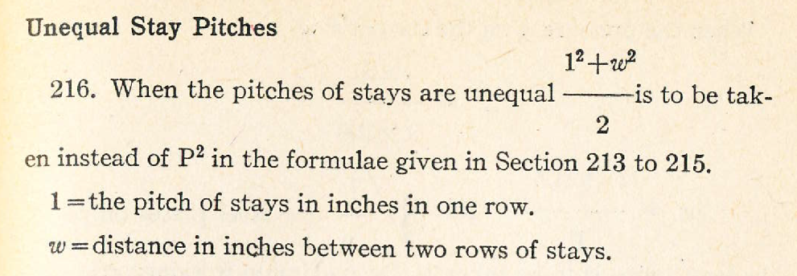
As shown in the following diagram, the red rectangle and the blue square share the same hypotenuse (black), although the blue square actually covers more surface area. The origins of this theory appear to be based in consideration for unsupported area and distance between stays, not supported area of each stay.

When the staybolt pattern is square, both equations yield the same results. Most staybolt patterns are very close to being square.
Furthermore, the current Swedish, Dutch (“AD-Merkblatt” by Verband der Technischen Uberwachuns-Vereine e.V.) and German (“Drutscher DampfkesselausschuB (DDA)” by Vereinigung der Technischen Uberwachungsvereine e.V. Essen) boiler codes provide equations that replace a rectangle with a circle. Here, the (brown) circle’s diameter is equivalent to the hypotenuse of both the original rectangle and of the theoretical square.

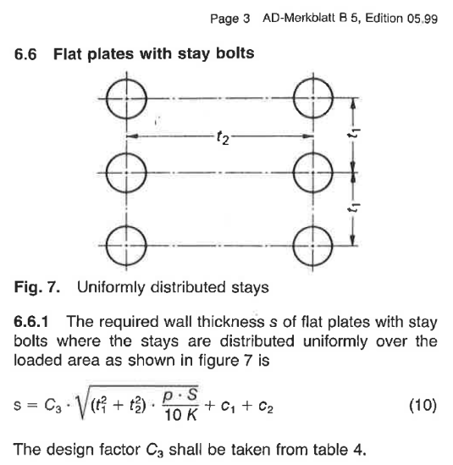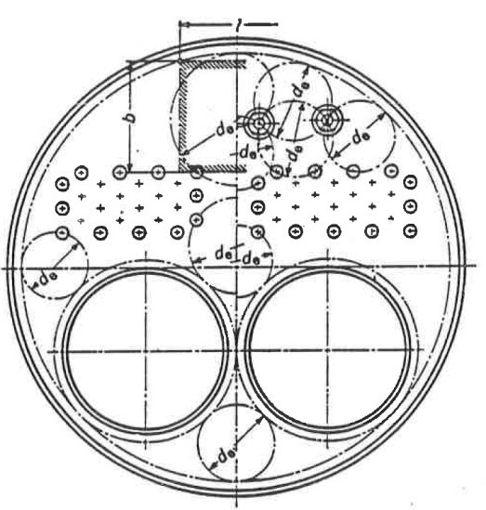
Dutch code German Code
Of note, that the approach to using a theoretical square or a theoretical circle is equal. The same results can be obtained by applying a linear scale from the square’s area to the circle’s area. Hence, we believe that all of these boiler codes apply the same underlying geometric theories, but apply different criteria and limitations to these theories. Since the European equations would require an additional scale factor and the historic Canadian equations do not, the proposal uses the Canadian equations only for clarity of presentation.

Example: Representative boiler dimensions and thicknesses: dimensions retrieved from a historical boiler blueprints, stated thickness deteriorated to 0.300 inches, staybolt pitch of 4.375x4.07.
l = 4.375
w = 4.07
t = 0.300
Currently:
Rectangular equations:
In this real-world example, the historical boiler MAWP has increased approximately 10psi, or about 7%.

