Date Distributed:
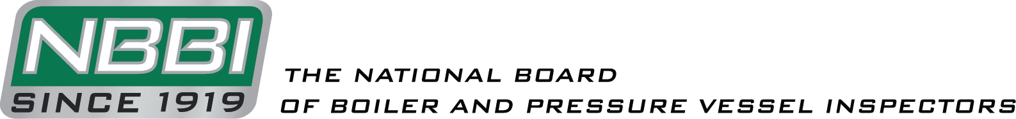

NATIONAL BOARD INSPECTION CODE
GRAPHITE TASK GROUP

AGENDA

Meeting of November 2nd, 2022
Clearwater, FL

The National Board of Boiler & Pressure Vessel Inspectors
1055 Crupper Avenue
Columbus, Ohio 43229-1183
Phone: (614)888-8320
FAX: (614)847-1828

- Call to Order
The Chair will call the meeting to order at 9:00am local time.

- Introduction of Members and Visitors

- Announcements

- Adoption of the Agenda

- Approval of the Minutes of the September 2022 Meeting
The minutes from the September 2022 meeting can be found on the National Board website on the NBIC Committee Information page under the Inspection Code tab.

- Review of Rosters
  - Membership Nominations
    - Mr. Jesse Wince was unanimously nominated to become a member of the Task Group during the September meeting. His membership will become official after receiving approval from Main Committee and the Chair of the Board of Trustees..

  - Membership Reappointments
    - The following memberships are set to end prior to the next meeting: Mr. Chris Cary, Mr. Nolan Lee, and Mr. Tracy Rudy.

  - Officer nominations
    - No new nominations.

- NBIC Business

Item Number: NB15-2208 | NBIC Location: Part 3, S3 | No Attachment
General Description: Investigate repair options for graphite block heat exchangers
Subgroup: Graphite

Task Group: G. Becherer (PM), Aaron Viet

September 2022 Meeting Action: Mr. Viet presented sketches of repairs that show common failures. Discussion was held on the necessity of potentially adding sketches of more in-depth repairs. Mr. Viet then asked if there are any failures missing that should be added. This led to discussion on the amount of material needed for routine inlay repair. It was decided that discussion should be put on hold to be discussed in a separate item. Mr. Viet sated that he will add titles and text for the sketches, and either point to an existing procedure or write up new procedure if an existing procedure for a sketch is not present in the NBIC.

Item Number: 19-73 | NBIC Location: Part 3, S3 | Attachment Page 1
General Description: Requirements for who can make hole plugging repairs on graphite blocks
Subgroup: Graphite

Task Group: C. Cary, A. Viet, A. Stupica (PM), S. Mehrez

September 2022 Meeting Action: Mr. Stupica presented a proposal for this item. Discussion was held on the proposal and the usage of “tube holes/block holes”. The task group will work further to see how to clearly word the section.

- New Business

Discussion from the September 2022 Meeting:
- Mr. Jesse Wince was present to discuss the possibility of adding graphite plate replacement to the list of routine repairs for graphite pressure vessels.
  - Replacing a plate would seem to make sense as a routine repair. Discussion was held on how it works in the metal world to get a comparison. The consensus was that this would be a routine repair for a G mark holder. Mr. Wince stated he would come up with a sentence for S3.3 and include description of graphite plates.

- Discussion was held on whether a G mark is required to disassemble a graphite pressure vessel to then perform a repair. Consensus was that disassembling and reassembling should not require the G mark, but the NBIC as it is currently worded seems to indicate that the G Mark would be required. The Task Group would need to write a separate paragraph on requirements for replacing parts without cementing. This led to questions about if replacing a block should be considered a routine repair, along with how to go about potentially writing in an exception or rewriting existing code language. Further discussion was held around what R stamp holders without the G mark should be allowed to do. A Task group of Mr. Viet, Mr. Wince, and Mr. Mehrez was put together to begin investigating solutions.

- The Task Group agreed that it would be good to gather ideas for inlay routine repair requirements to discuss at next meeting.

- Future Meetings
NBIC Meeting – January 9th-12th, 2023 – Charleston, SC
TG Graphite Meeting – To be determined.

- Adjournment

Respectfully submitted,
Jonathan Ellis
Jonathan Ellis
NBIC Secretary

