Date Distributed:
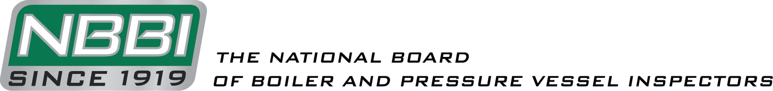

NATIONAL BOARD INSPECTION CODE
TASK GROUP LOCOMOTIVE BOILERS

AGENDA

Meeting of November 3rd, 2022
Virtual Meeting using Zoom

The National Board of Boiler & Pressure Vessel Inspectors
1055 Crupper Avenue
Columbus, Ohio 43229-1183
Phone: (614)888-8320
FAX: (614)847-1828

- Call to Order

1:00 PM Eastern Time.

- Introduction of Members and Visitors

- Check for a Quorum

- Announcements

- Adoption of the Agenda

- Approval of the Minutes of the October 2021 Meeting

The minutes are available for review on the National Board website, www.nationalboard.org.

- Review of Rosters (Page 4)

  - Membership Appointments

  - Membership Reappointments

    - The following TG Locomotive memberships are set to expire in January 2023: Mr. Mark Ray, Mr. Rick Musser, Mr. Steven Butler, Mr. Robert Franzen, Mr. David Griner, Mr. Matthew Janssen, Mr. Stephen Lee, Mr. Doyle McCormack, and Mr. Linn Moedinger.

  - Officer Elections
    - Mr. Mark Ray’s term as Chair is set to expire in January 2023. He is eligible for reappointment to the position.
    - Mr. Rick Musser’s term as Vice Chair is set to expire in January 2023. He is eligible for reappointment to the position.

- Interpretations

None

- Action Items

New Business:
- At the previous meeting, Mr. Griner held a discussion session with the TG on the performing of RT on the long seams of boilers greater than 100 years in age. After extensive discussion the TG came to the conclusion that it may be good to compose a proposal and open up a new item to address this topic. Mr. Ray also suggested having someone from NDE join a meeting so as the TG can gain a better understanding of incorporating RT.

- Discussion Items

- Future NBIC Meetings

- January 9-12, 2023 – Charleston, SC
- July 2023 - TBD

- Adjournment

Respectfully submitted,

Michelle Vance
TG Locomotives Secretary
Page 1
Committee Roster
