# Date Distributed:

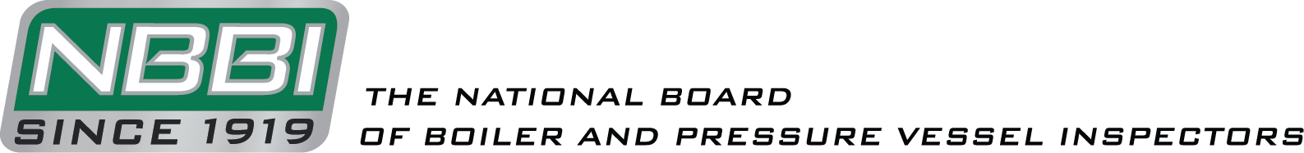

**NATIONAL BOARD INSPECTION CODE**

**FRP TASK GROUP**

AGENDA

Meeting of April 17th, 2023

Zoom Meeting

The National Board of Boiler & Pressure Vessel Inspectors

1055 Crupper Avenue

Columbus, Ohio 43229-1183

Phone: (614)888-8320

FAX: (614)847-1828

1. **Call to Order**

The meeting is scheduled to begin at 1:00 p.m. Eastern Time.

1. **Introduction of Members and Visitors**
2. **Announcements**
3. **Adoption of the Agenda**
4. **Approval of the Minutes of October 2022 Meeting**

The minutes can be found on the National Board website: <https://www.nationalboard.org/Index.aspx?pageID=13&ID=18>

1. **Review of Rosters**
   1. Membership Nominations
      1. None.
   2. Membership Reappointments
      1. None.
   3. Officer nominations
2. **Action Items**

|  |  |  |
| --- | --- | --- |
| **Item Number: NB16-1402** | **NBIC Location: Part 2** | **No Attachment** |
| **General Description:** Life extension for high pressure vessels above 20 years | | |
|  | | |
| **Subgroup:** FRP  **Task Group:** M. Gorman (PM), N. Newhouse, J. Eihusen  **October 2022 Meeting Action:** Mr. Gorman provided background information on this item to refresh the committee’s memory. He also provided a recap on discussion of this item at previous meetings. Discussion was held on having Subcommittee Inspection review the new proposal prior to approving it at the task group level. Mr. Gorman will plan to attend the January 2023 SC Inspection meeting to discuss proposal updates and will plan to share the proposal at the April Task Group meeting. | | |

1. **Additional Business**

From previous meeting:

* At the October 2021 meeting, Mr. Shelley asked Mr. Brown to investigate Supplements 4 and 10 in Part 2 to make sure that the inspector references only refer to the R stamp inspector. Mr. Brown found a few instances of the use of “Inspector” where it should actually refer to “inspector”. He stated that he will have a proposal ready to review at the next meeting.

1. **Future Meetings**

July 10th-13th, 2023 – NBIC Committee Meeting

October 2023 – TG FRP Meeting

1. **Adjournment**

Respectfully submitted,

Jonathan Ellis

Secretary